Fact sheet 7: For people with psychosocial disability and their families

New NDIS early intervention pathway to support personal recovery

The panel’s vision
There needs to be a new dedicated approach for people with psychosocial disability that better meets their episodic needs and is focused on personal recovery.
We want to create a more joined up system of support so there is help outside and inside the NDIS.
People with psychosocial disability should have more support to access non-clinical mental health and psychosocial capacity building supports to support their recovery, increase their independence and inclusion in community. There also needs to be better connection to and support from mental health clinical services.

What is the problem?
The NDIS has not always supported people with psychosocial disability well. There is not enough support outside NDIS and the scheme does not work well with the broader mental health system. This particularly affects people with complex needs who need support from both systems.
We have heard that NDIS processes for access, budget setting and planning don’t respond well to the changing needs of people with psychosocial disability. The NDIA and Partners in Community don’t always seem to have a good of understanding of the needs of people psychosocial disability and don’t always work in a trauma-informed way.
There is not always a good match between people’s needs and the services available and it’s difficult to find workers with the right skills, training and experience.

What is the solution?
The NDIS should support people with a high level of need, including people with significant psychosocial disability. But we also need more support for people who are not eligible for the scheme.

Within the NDIS
There should be a new dedicated approach based on personal recovery and increased independence that is more responsive to episodic needs.
We recommend:
- A new specialist early intervention pathway into the NDIS for most new participants with psychosocial disability to support personal recovery as soon as possible. Participants could stay in this new pathway for up to three years.
- Participants could choose from time-limited early intervention supports which have been shown to be effective, including support to find and maintain housing, self-management of illness, information and support for employment, and support for families. Participants could also have access to services that support them to carry out daily activities if needed, similar to core supports provided through the scheme now.
- Participants should also receive support from a psychosocial recovery navigator. This navigator should have specific experience and training in psychosocial disability. They should help participants to find and organise support in a way that works best for them.
- Navigators should work with participants to understand their journey and what treatments and supports they have tried. They should help participants find evidence-based supports to live the life they want to lead and to connect with mental health services, education and employment.
- The majority of participants with psychosocial disability who will likely need lifetime support from the scheme after the three year early intervention period should continue to be funded by the NDIS under the permanent disability pathway (Section 24 of the NDIS Act).
- It is important to remember that both pathways mean a participant is “in” the NDIS - they are just different ways to access the scheme with different requirements.
- Participants who no longer need the NDIS because their support has been effective could then move into mainstream or foundational psychosocial supports. They should still be supported by their psychosocial recovery navigator.
- Like other NDIS participants, budgets for psychosocial participants should be set after a support needs assessment is completed. Budgets should recognise their episodic need for support and should be based on what is needed on a “bad day”. Like other participants, budgets should be flexible so people can use it in ways that support them best.
- New practice standards should be in place for service providers and workers who deliver psychosocial disability-specific supports to improve outcomes. Providers would need to be registered to ensure appropriate training, skills and expertise.
- Better coordination and integration between the NDIS and mental health clinical services that is person centred.

Foundational supports for people not eligible for the NDIS
We also recommend:
- Greater availability of foundational supports designed to meet the needs of people with psychosocial disability who are not eligible for the NDIS. Foundational supports should include information and capacity-building programs, peer support, and recovery colleges. There should also be non-clinical services to help with relationships, daily living skills, housing and education.
- A coordinated approach between the NDIS foundational supports and public mental health systems for people with complex support needs who require active mental health management.
- More “step-up, step-down” mental health residential services to support participants in community.

Who will this benefit?
People with psychosocial disability should have greater access to foundational supports, whether they are in the NDIS or not. Families should be also better supported. There should be easier access for new participants to time-limited, NDIS early intervention psychosocial supports to build independence and capacity and support personal recovery as soon as possible. Participants with significant lifetime support needs after the three year period should transition to the permanent NDIS pathway. Families should be also better supported.

What happens next?
We know you might be worried about what this will mean for you. We strongly recommend that people with disability, their families and representative organisations are closely involved in designing and testing these changes, to make sure they work well. We also recommend that they are introduced gradually so everyone has time to get ready.
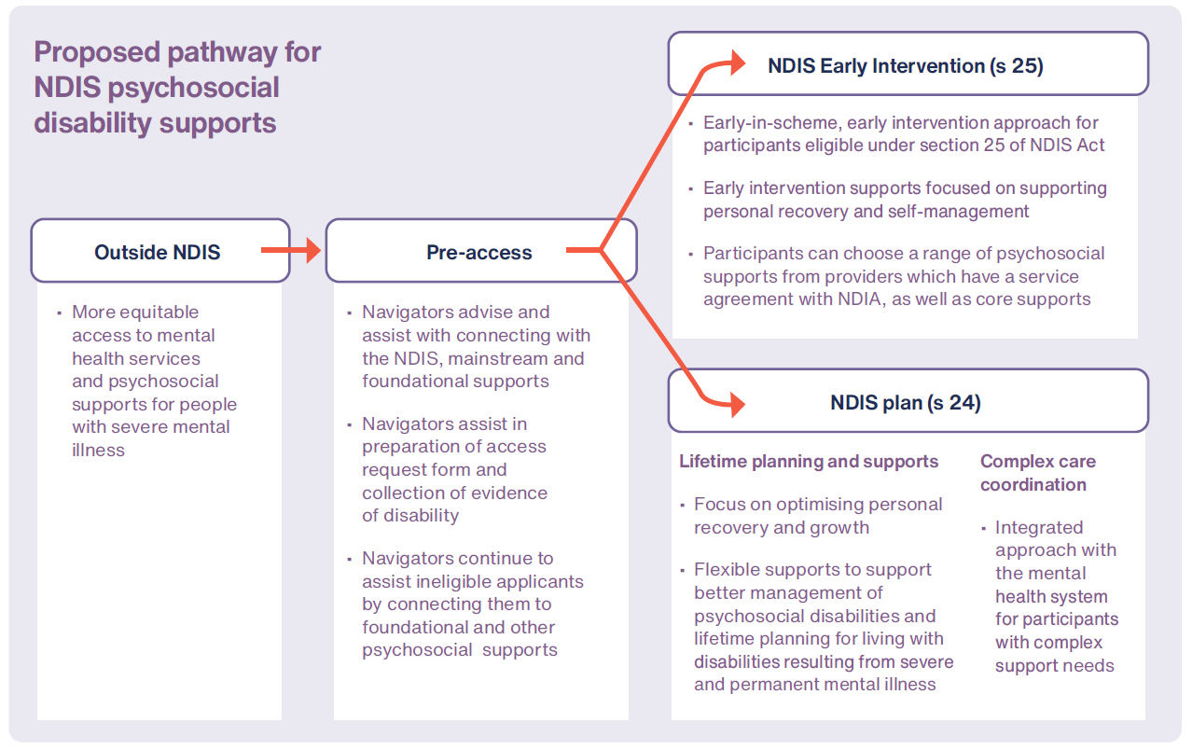

Brett has a borderline personality disorder and enters the NDIS through the early intervention pathway.

How the future NDIS participant experience could work

Case Study
Brett has a borderline personality disorder and enters the NDIS through the early intervention pathway.
Brett has a borderline personality disorder which significantly impacts his daily life and resulted in a breakdown in his relationships with his family and friends and his fellow workers. He has a significant psychosocial disability and the mental health treatments he has received have made no difference. Brett enters the NDIS through the early intervention pathway as his psychosocial disability is likely to be permanent and also has a significant impact on his daily life.
He is connected to Mary, through the local navigator hub and she introduces him to a service provider that has experience in supporting people with psychosocial disability. With Mary’s support, Brett chooses the web-based resources, joins a peer support group and the social skills program offered by the service. He also decides to ask his cousin and a work colleague to attend the educational programs run for family and friends. Mary helps Brett connect with a new mental health service which bulk-bills and he continues treatment.
After two years, Brett considers that his daily living and social interaction skills have improved but comes to recognise that he will have significant disability support needs throughout his life. He asks Mary to assist him with transferring to lifetime supports through a section 24 application. Mary assists him with his access application and he transfers to lifetime psychosocial supports through the NDIS under section 24.
Brett felt that the early intervention service helped him be as independent as he could be, supported him to seek more mental health treatments and come to terms with having a lifelong disability. The early intervention service helped him to understand what the NDIS could offer and how to change his supports to his changing needs and improve his confidence and skills in managing his psychosocial disability and his mental wellbeing. He gets on better with his family, friends and work colleagues.
Want more information? Read the final NDIS Review report and recommendations, NDIS Review Guide, NDIS Review fact sheets and FAQ at www.ndisreview.gov.au

