Alternative commissioning
for remote and
First Nations communities
  - June 2023

Contents
Overview 2
1. Market challenges limit the ability of the NDIS to deliver quality supports for participants 5
2. Efforts to date have been too narrow 12
3. Opportunities for more culturally appropriate and sustainable services in First Nations communities and remote communities 19
4. Implementing a placed-based, community-driven alternative commissioning approach 29
5. Next steps 36
Appendix 1 – Text descriptions 37

Overview
The National Disability Insurance Scheme (NDIS) has changed the way disability supports are delivered. The current market-based approach to deliver NDIS supports has provided many participants with greater choice and control in their lives.
We also know that, in some areas, market challenges are limiting the ability of the NDIS to deliver on its promise for participants to live an ordinary life.
Many of these market challenges are already well known. Many reviews have outlined the issues with taking a ‘one-size-fits-all’ approach to the NDIS. Yet these challenges are still plaguing the scheme today – and leaving some participants behind. Gaps in delivery are particularly evident for both First Nations and remote communities who are being left behind under the rigid market approach.
The National Disability Insurance Agency (NDIA) has taken some important first steps to trial more flexible market approaches in the NDIS. This includes starting to build partnerships with communities. However, these are just first steps – more needs to, and can, be done.
Governments can play a more active and flexible role as ‘stewards’ of the NDIS market. Throughout the NDIS Review, we will continue to work with you to come up with solutions on how we can strengthen market stewardship in the NDIS to deliver outcomes for all participants.
Some steps can be taken now to address persisting market gaps in remote and First Nations communities.
Alternative commissioning – where a ‘commissioner’ contracts a provider to support a group of participants – is not a new idea. Many past reviews of the NDIS have called for these arrangements to be used when competition in markets are failing participants.
When placed-based and community-driven, alternative commissioning could help the NDIS to deliver more culturally appropriate, efficient and sustainable supports for First Nations communities and remote communities. Partnerships between First Nations organisations and experienced disability service providers will also be critical in building understanding of disability and capability to deliver supports in a culturally safe and inclusive way for communities. Over time, communities should be supported to buy and coordinate the supports for themselves. Where they wish to, communities could design the approach and lead the commissioning process.
Over the coming months, we will work with First Nations representatives, communities and governments on how alternative commissioning approaches could be implemented in the NDIS.

Key points
- Over the past decade, significant market development in the NDIS has improved outcomes for many participants.
- For others, a fully individualised and market-driven approach has left them with limited access to supports. This includes gaps in delivery for First Nations participants and in remote communities who are being left behind under the rigid market approach, and a persistent lack of culturally appropriate supports. Ten years on, available data shows that a small number – including just 40 members of the National Aboriginal Community Controlled Health Organisation (NACCHO) – are providing supports as registered NDIS providers.
- While increases in remote and very remote price loadings and more flexible pricing arrangements (for example, to cover telehealth) have addressed some challenges in these areas, persistent market gaps remain.
- In remote and very remote Australia, over one in three participants – who have been in the NDIS for over one year – are not accessing daily activity supports, and over one in four are not accessing therapy supports.
- Over the past five years, many reviews have repeatedly called for alternative commissioning approaches to address persistent market gaps, particularly in remote communities. While the NDIA’s thin market trials have explored a few commissioning approaches, efforts to date to improve market functioning have been too narrow.
- A more active and flexible role for governments, as stewards of the NDIS market, is needed. The Review is exploring how a range of market mechanisms could be applied and scaled up in the NDIS to address persistent market challenges. Even so, steps should be taken now to address the most pressing market gaps.
- Addressing market gaps for both remote and First Nations communities requires a different market approach that can better coordinate supports. In these cases, alternative commissioning arrangements that are placed-based and community driven could lower the cost of service delivery by offering service providers greater certainty of demand. This could also increase their ability to achieve scale and continuity of supply.
- Alternative commissioning arrangements would enable culturally appropriate supports to be delivered by a more localised workforce. These approaches could also improve outcomes for participants and drive a more sustainable care and support ecosystem over time.

- Ongoing, meaningful and on-the-ground partnerships with First Nations representatives, communities and participants will be key to success. The National Agreement on Closing the Gap, its Priority Reforms and the Disability Sector Strengthening Plan offers a framework to progress alternative commissioning in genuine partnership with the First Nations people with disability, families, communities and organisations.
- Expanding too far, too fast is a significant risk. Time is needed to build commissioning capability and roll out alternative commissioning approaches across both remote and First Nations communities. Piloting approaches will help to understand what works and allow time to develop and strengthen community partnerships.

Market challenges limit the ability of the NDIS to deliver quality supports for participants
The NDIS has transformed the way disability supports are delivered.
Shifting from a government, block-funded model to a market-based model with individualised funding has enabled NDIS participants to have choice and control over the providers they work with and, to the extent allowed within their individualised budgets, what supports they access.
With this shift in funding also came a significant increase in scale and diversity of demand for services. Significant market development has occurred – over 350,000 participants are now receiving disability supports for the first time. But this growth has not been sufficient to secure access to quality services across all participants, supports and locations.
Past reviews of the NDIS indicate a range of ongoing market challenges that reflect more than just transition issues (Figure 1).
Moving from block funding devolved responsibility for coordinating access to support from governments to individuals and the market. The shift relied on individual participants, their families and market intermediaries having the capacity and capability to do this in an already complex environment, with little (or at least unclear) protection for participants where markets fail.
For some NDIS supports, competition between multiple service providers have not been able to effectively ensure access to supports for participants. It has been difficult for participants to find and match with suitable service providers, and for providers to achieve economies of scale and to ensure continuity of supply for these supports.
Thin markets – where the number of providers or participants is too small to support the competitive provision of services, or to support any provision at all – have left some participants with limited, or no, access to supports or certain types of supports.
Under the current market-based approach, some mature participants are not accessing supports despite having the budget to do so. This is most stark in remote and very remote communities where over one in three mature participants – participants who have been in the NDIS for one or more years – are not accessing daily activity supports, and over one in four are not accessing therapy supports that assist with building skills and independence.
Markets for certain supports are also thin in non-remote areas, particularly for specialised services like behaviour supports and for First Nation participants to access culturally safe supports (Figure 1).
As far back as 2017, the Productivity Commission found thin markets have been, and will continue to be, a persistent feature of the disability support sector. And in the absence of government intervention there will be greater shortages, less competition, and ultimately poorer outcomes for participants.
- Current market challenges are not just transition issues
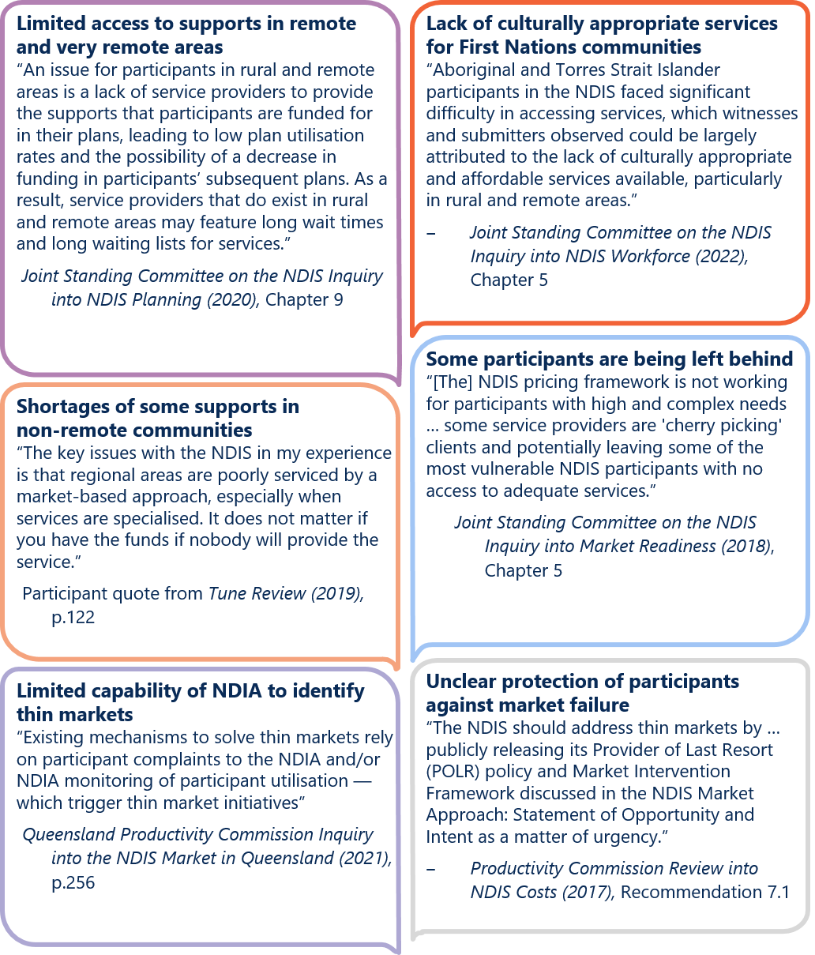
Figure 1 text description
- Participants, who have been in scheme for over a year, are still not accessing the supports they need
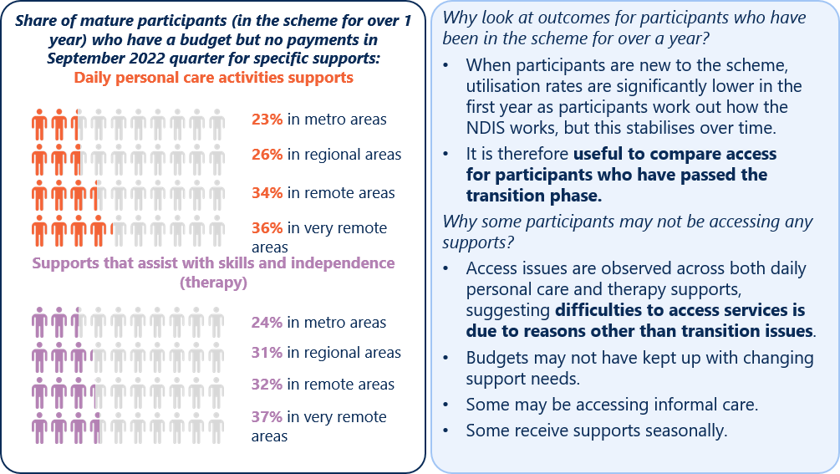
Note: This data is provided at 31 December 2022, allowing for a 3-month payment lag. It excludes in-kind supports.
Figure 2 text description

What does this mean for governments as market stewards?
Governments’ stewardship role in the NDIS, and other social services (such as community housing services) is broad. They have a role in supporting informed participant choice, access to quality supports, ongoing service improvements, and ensuring appropriate safeguards are in place (Figure 3).
- What is the role of market stewards in the delivery of social services?
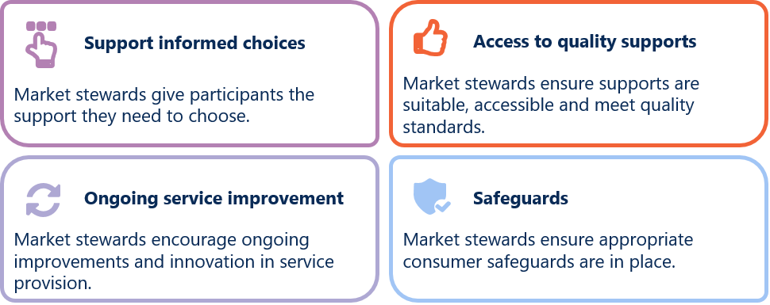
Even when using market-driven service delivery approaches, governments (as market stewards) retain responsibility for ensuring the NDIS, as a whole, delivers the intended outcomes for all participants.
As highlighted above, while the NDIS has improved outcomes for many participants, the rigidity in the current market approach is leaving others behind. Lack of clear roles and responsibilities across governments are also hindering coordination of market stewardship efforts.
The NDIS is not one market, but a complex system of ‘sub-markets’. For the NDIS to deliver outcomes for participants, there is no one-size-fits-all approach to service delivery or market stewardship.
For each sub-market, market stewards need to design a service delivery approach that reflects the nature of NDIS participants, supports and providers (Figure 4).
- Designing an effective service delivery approach for social services requires an understanding of the characteristics of participants, supports and providers
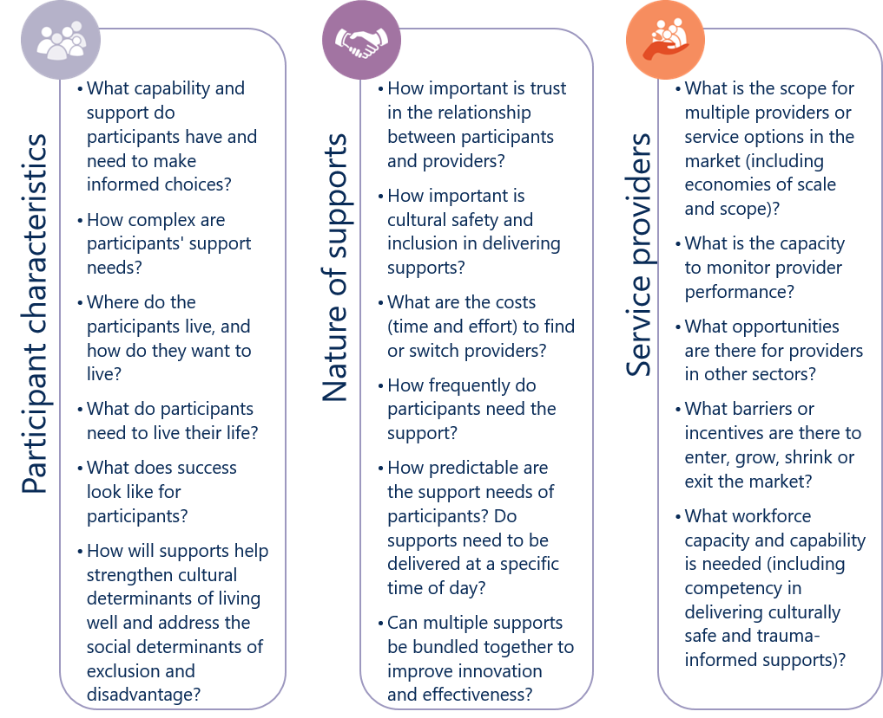
Figure 4 text description
Service delivery approaches may differ, for example, across:
- Assistive technology and other capital supports – these supports are often one-off in nature. Participants and regulators can more easily monitor and compare quality.
- Capacity building supports – these supports depend heavily on trusted relationships to be delivered. Providers are also likely to have opportunities to deliver in other sectors, such as health and aged care.
- Core supports – these supports (particularly for personal care) also depend heavily relationships, and support needs can vary across participants (for example, between children and adults). Typically these are ongoing and need to be delivered face-to-face. Often limited scope exists for multiple providers in remote contexts.
- Communities – Different communities may share different attitudes, beliefs and values. Trust, cultural safety and trauma-informed approaches will be critical for delivering quality and safe supports.
An understanding of participants, supports and providers can also help market stewards to consider which market-based tools – such as competition, and contestability – may drive the best outcomes for participants and governments (Figure 5).

Choice, competition and contestability in the NDIS
Choice and control has been foundational to the design of the NDIS. Informed choice empowers participants to have greater control over their lives.
When markets function well, competition between providers can offer more choice to participants, and help deliver more effective supports and better outcomes for NDIS participants. Participants can choose to leave poor performing providers who deliver low quality, low value or potentially unsafe services, and shift their funding to providers who deliver safe, high quality supports that are better value for money. In this way, competition in markets can help achieve the mix of supports and providers valued most by participants.
The first decade of the NDIS has been characterised by the assumption that, once mature, the market for disability services will function well. In practice, this has not happened for all participants and support types.
There are many reasons why a market may not work. Equally, there a lots of ways government can ‘intervene’ to improve how NDIS markets function and, ultimately, improve outcomes.
Market stewards can use a number of tools or ‘market mechanisms’ to underpin a competitive market approach. This includes market coordination and market setting arrangements (Figure 5). For example, price caps is a key market tools currently used by the NDIA in its market stewardship role.
- Market stewards have a range of market tools to help ensure the effective delivery of supports and, ultimately, outcomes for participants
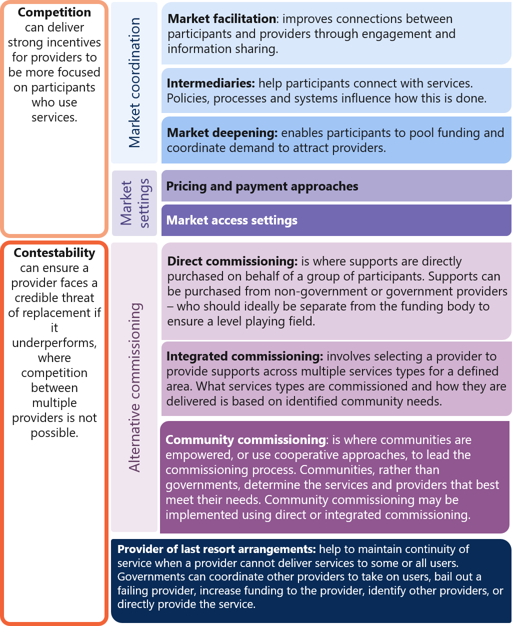
Note: Adapted from the 2019 NDIS Thin Markets Project – Approach to Thin Markets Final Report.
Figure 5 text description

However, competition between multiple service providers is not always possible. In these cases, contestable arrangements can be used to select providers (using ‘alternative commissioning’ arrangements) to improve the operation of the market and deliver better outcomes for participants.
A contestable market (including one with a single active provider) can help ensure providers are responsive to participants where there is a credible threat of replacement. Contestability can achieve many of the benefits of competition without experiencing the drawbacks when the conditions for strong competition are not met. Contestability can be applied at different levels in the market:
- at the ‘service level’ for a group of participants
- for a ‘bundle’ or ‘wrap around’ supports for an individual or group of participants
- at the ‘whole of market’ level for a community.
Using alternative commissioning – where a government or community assumes the role of the commissioner – does not necessarily equate to block funding. Rather, alternative commissioning can include a range of design choices, including place-based and community-driven approaches (Figure 5).

Efforts to date have been too narrow

The NDIA’s thin market trials suggest market facilitation alone is not sufficient to overcome challenges in thin NDIS markets
In 2019, the Disability Reform Council (DRC) acknowledged the need to use a more flexible approach to address market challenges following the development of the NDIS Thin Markets Framework commissioned by Department of Social Services (DSS).
The Council agreed to use a more flexible approach to address market challenges in the NDIS, recognising that a ‘one-size-fits-all’ approach to delivering the NDIS is not suitable to address market gaps faced by certain geographic locations, particular cohorts or disability support types.
The NDIA subsequently undertook 13 thin market trials across each state and territory as agreed with the DRC. Twenty-six additional thin market projects have also been initiated by the NDIA where potential supply gaps have been identified.
The trials focused on mechanisms to improve market information, assisting participants to pool funding or using direct commissioning arrangements to purchase supports at a group level (Figure 6).
An evaluation of the trials found market information provision was not sufficient to overcome challenges in thin markets, implying more active interventions were needed (Figure 6).
Coordinated funding proposals (CFPs) demonstrated some success in improving access to services for remote and very remote communities. CFPs allowed participants to pool their demand by collecting their funding and coordinating what services they needed. This helped participants to attract providers to deliver specific services, deepening the market. However, most CFPs have focused on one-off functional assessments and/or assessments to support ongoing therapies. Testing CFPs across a wider range of support types and locations is needed.
The success of CFPs were found to rely heavily on support coordinators working together. For example, the Mornington Island Thin Market Trial saw an increase in average participant plan expenditure from $652 in the year before the CFP commenced to $7,027 in the year after the CFP commenced. Improvements were largely attributed to the ongoing engagement of the CFP working group with NDIA assistance (Case Study 1).
The evaluation, however, highlighted mixed success in being able to get support coordinators to work together. This was reported to be a factor in some CFPs not proceeding.
With some CFPs not progressing, it is unclear whether CFPs can overcome market coordination issues to ensure continuity of supply and support investment in local service delivery in remote communities.

Box 1 Defining remote areas
The NDIA uses the Modified Monash Model (MMM) to categorise locations in Australia according to their population and distance from capital cities. MMM classifications are based on the Australian Statistical Geography Standard – Remote Areas (ASGS-RA) framework used by the Australian Bureau of Statistics (ABS).
For the purpose of this paper, the NDIS Review has defined remote areas as those in MMM categories 6 to 7 – that is, “remote” will include remote and very remote communities.
NDIA have recently released resources for participants, families, carers, and support coordinators to develop and use CFPs to access safe, quality supports they need. Monitoring the uptake of, and associated outcomes from, CFPs will be key to determining whether they can overcome market coordination issues and deliver on what is most important to participants.
Direct commissioning trials were applied in a handful of circumstances and with mixed success (Figure 6). While the evaluation found that direct commissioning increased assurance of demand for service providers in the few trials undertaken, the increase in NDIS spending was marginal outside of the one very remote trial.
In the very remote trial, the increase in spending may not have reflected an increase in participant use of supports. Parts of the community were unclear about how the NDIA captures, monitors and responds to feedback on how well the directly commissioned service is working for participants in the community. This included feedback about how culturally safe and appropriate the supports are.
The NDIA thin market trials have also not addressed the underlying drivers of thin markets – particularly in how they relate to market settings, including price settings – which has resulted in limited success in improving participant outcomes.
NDIA’s approach to identifying, prioritising and intervening in markets is largely informed by data on utilisation and participant spend. There is limited visibility of the unregistered provider market and little market sounding to understand the nuances in these areas.
NDIA’s approach is currently not public. Publicly available market monitoring data is not enough for communities to raise issues or respond to emerging thin markets. It is unclear how participants and providers can raise concerns about thin markets and this is creating uncertainty about the continuity of supply when markets fail.
Importantly, the evaluation of the thin market trials did not follow best practice Indigenous evaluation approaches. The lack of First Nations voices makes it difficult to make any robust conclusions, and learn from what has or has not worked for these communities.
- What did NDIA’s evaluation of thin market trials find?
 | Market facilitation to improve connections between providers and participants, such as focused engagement and sharing targeted market information | Market facilitation has featured in almost all 39 thin market trials since 2019.  There is no evidence that, on average, market facilitation trials increased participant use of NDIS supports or strengthened local NDIS markets above all other activities undertaken by the NDIA or other market intermediaries.  Feedback from service providers and support coordinators indicated that market facilitation activities were insufficient to encourage greater service provision and to overcome systemic market challenges – such as workforce shortages and participants’ limited understanding of the NDIS.
 | Coordinated funding proposals (CFP) to enable participants to pool NDIS funding to more efficiently secure services from providers | CFPs have been, or are being, trialled across nine remote and very remote communities.  Trials have shown success at pooling participant demand, particularly for participants to access one-off functional assessments. CFPs help service providers – mainly based outside the community and travelling by road or air – to mitigate demand uncertainty, and share travel and administration costs.  However, to understand the potential of CFPs, they need testing across a wider range of support types and locations.  Main challenges with CFPs appear to be the logistical challenge for service providers to coordinate service delivery across multiple support coordinators who are not always based in the community.
 | Direct commissioning directly contracts providers to deliver support to a participant or a group of participants | Only three trials used direct commissioning.  Only one trial was run in a remote context, and it was limited to community, social and civic participation supports. While it is still too early to assess, the NDIA expects a projected increase of around 119% (or over $10,000) in average annual participant expenditure for these supports.  For non-remote trials, direct commissioning had only a marginal increase in use of NDIS supports – that is, an increase of less than $250 per participant each year. Providers also reported substantial financial and administrative burden arising from additional claiming processes and reporting requirements.

Case Study 1 Mornington Island Thin Market Trial
NDIA commenced a CFP trial in Mornington Island – with over 20 participants residing in this very remote area – of which over 70% identified as First Nations people. When the NDIA commenced the trial in March 2020, average plan utilisation was 49.1%, indicating severe market gaps and significant low utilisation of NDIS funding.
As part of the trial, the NDIA conducted market facilitation activities for support coordinators and service providers. The NDIA also set up a CFP working group for participants’ support coordinators. CFP helped to secure an allied health provider to fly in and deliver functional capacity assessments for 14 trial participants, with an additional participant receiving supports who was not part of the trial.
The NDIA’s evaluation of the trial found very little evidence that the market facilitation activities in the community has improved utilisation. However, the NDIA also found that after 10 months of operating, the CFP had significantly increased participant access to, and expenditure on, allied health supports.
The average participant plan expenditure 12 months before the CFP commenced was $652, and 12 months post CFP it had increased to $7,027.
NDIA attributes the increase in utilisation to the continuation of the CFP working group as a support coordinator community of practice. NDIA remote planners are heavily involved in facilitating and coordinating this group to identify and address service gaps in Mornington Island.

A more active and flexible approach to market stewardship of the NDIS market is needed
The NDIA has been using a ‘least interventionist approach’ to achieve a better functioning and sustainable market, despite recognising some thin markets may require several market interventions to be delivered iteratively over a long term.
This approach, however, reflects a more rigid and time-limited application of a stewardship framework more suited to private sector markets.
Social services, including the NDIS which is fully funded by government, are best described as ‘quasi markets’. These markets require a higher level of market intervention relative to private sector markets.
Governments do more than just set the rules of engagement or act as a funding body. As market stewards, governments also oversee these markets and intervene when necessary. They need to monitor outcomes and carefully balance considerations of efficiency, effectiveness and equity.
Alternative commissioning approaches in the NDIS are yet to be explored extensively despite the pressing need.
… rigid adherence to individualisation can have a negative effect, particularly when it is clear that some participants cannot access the supports they need, even when a robust market has been established.
– Tune Review 2019
Past reviews and inquiries have repeatedly called for alternative commissioning approaches to be explored where market approaches are failing – particularly for remote and very remote communities (Figure 7). Yet only three trials used direct commissioning, and only one was undertaken in a very remote context.
The market coordination tools, which have been used throughout the thin market trials, have an important role to play in the broader delivery of the NDIS and in building these market structures. They lay the groundwork for future approaches to thin markets and highlight implementation considerations and challenges.
- Numerous past reviews and inquiries recommended alternative funding
and alternative commissioning approaches, particularly for remote and
very remote communities
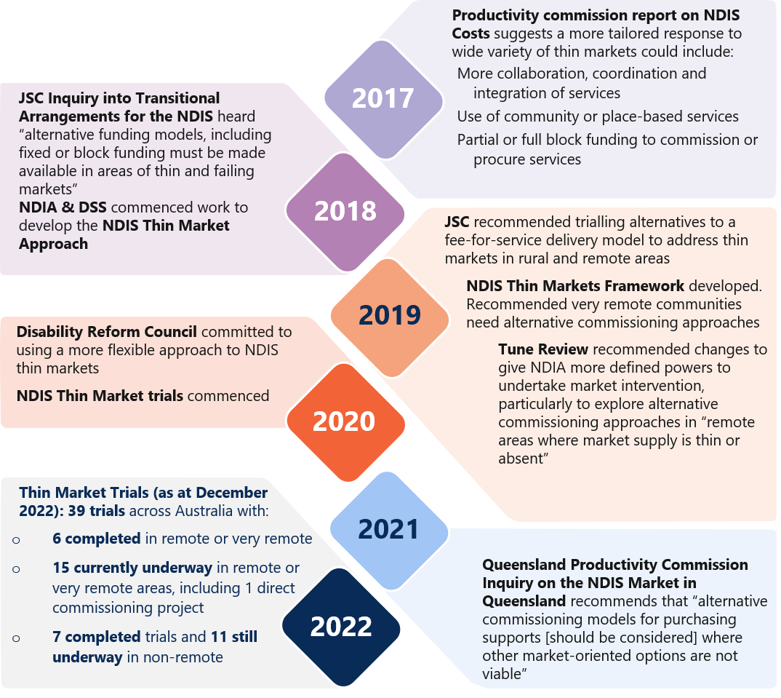
Figure 7 text description

Finding 1 Market stewardship efforts to date have been too narrow
Previous reviews have called for employing alternative commissioning approaches to address persistent market gaps, particularly for remote communities. However, few alternative commissioning approaches have been explored in the scheme.
A more active and flexible role for governments as stewards of the NDIS market is needed to address persistent market challenges.
The NDIS Review is exploring and engaging with relevant parties on how to build on the learnings of the recent thin market trials to consider how market coordination tools and other market mechanisms could be applied and scaled up in the NDIS.
Even so, steps should be taken now to address some of the most pressing market gaps for First Nations participants and remote communities (which include First Nations and non-Indigenous participants).

Opportunities for more culturally appropriate and sustainable services in First Nations communities and remote communities
Evidence from past and ongoing reviews and inquiries continues to show that the current market-based model with individualised funding arrangements persistently fail to meet the needs of both First Nations and remote communities.
Whilst there are thin markets and gaps in available disability services and supports in all locations that are culturally inclusive and safe, there are additional thin market challenges in rural, remote, very remote locations. For example, cost, existence of community-controlled organisations already delivering a range of services with different reporting, regulatory and governance requirements, workforce, and appropriate infrastructure. This exists for both NDIS and non-NDIS related service delivery.
– Closing the Gap Disability Sector Strengthening Plan 2022
The NDIS has gone some way to improving equity in access to supports for First Nations people with disability. As at 31 December 2022, 7.4% of NDIS participants identify as First Nations participants. Over 60% of First Nations participants in remote and very remote communities are receiving disability supports for the first time.
However, First Nations participants and participants living in remote communities still face persistent challenges in accessing NDIS supports. Broader systemic issues around the participant experience with the NDIS are exacerbated.
We have received inconsistent advice on whether ‘return to country’ for short visits to connect with family, or participate in ceremony, is funded under the NDIS as some planners have considered those visits as a holiday rather than a cultural, necessary and reasonable support requirement.
– Somerville Community Services
Improving outcomes for First Nations participants require accessible, culturally appropriate NDIS supports that take into account the strengths of First Nations communities.
A historic lack of services within remote communities pre-dates the NDIS and has led to limited or no knowledge and understanding of disability supports. In remote communities, the increased demand for services - which has been driven by the NDIS – has often not been met with an increase in services.

Community-driven alternative commissioning approaches can strengthen the community-controlled disability sector
Complex NDIS policies and processes have made it difficult for First Nations people with disability to access and navigate the NDIS. The relatively low number of First Nations participants with a plan and the cultural appropriateness of planning processes were among the many concerns raised during the 2020 Joint Standing Committee Inquiry into NDIS Planning.
Compared to non-Indigenous participants, First Nations participants have higher value plans. Lower levels of plan utilisation arise from lower levels of spending.
Limited availability of accessible, culturally appropriate care and supports (Figure 8) may mean First Nations participants need to choose between getting culturally unsafe supports, and not getting funded supports at all.
Aboriginal people will only access those services where they feel culturally safe and prefer to use Aboriginal community-controlled health services when available.
– Aboriginal Health Council of South Australia Ltd (AHCSA)
First Nations community-controlled organisations may be reluctant to deliver NDIS services. Individualised funding packages can provide uncertain funding for community-controlled organisations, limiting their ability to build trust within the communities they are supporting. This uncertain can also limit their ability to invest in longer term staffing contracts.
- As at December 2022, a small number – including just 40 members of the NACCHO – are providing supports as registered NDIS providers
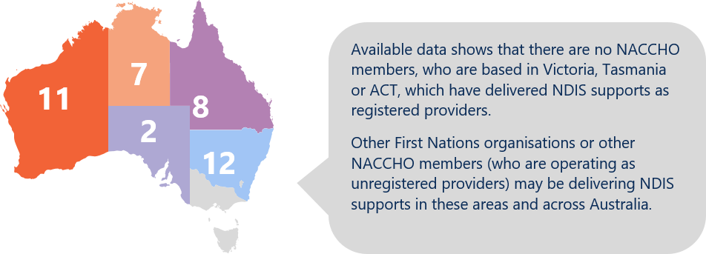
Note: Data only includes organisations who are members of the NACCHO, are registered NDIS providers, and have previously delivered and claimed supports against an NDIS participant’s plan as at 31 December 2022.
Source: NDIA data, December 2022 (unpublished)
The capacity of First Nations communities – which include First Nations people with disability, their family and kin, community, and provider organisations – to drive and develop culturally appropriate care and supports is also being hindered in the current approach (Figure 9).
- Market-based model with individualised funding arrangements works against First Nations community-led decision-making and initiatives
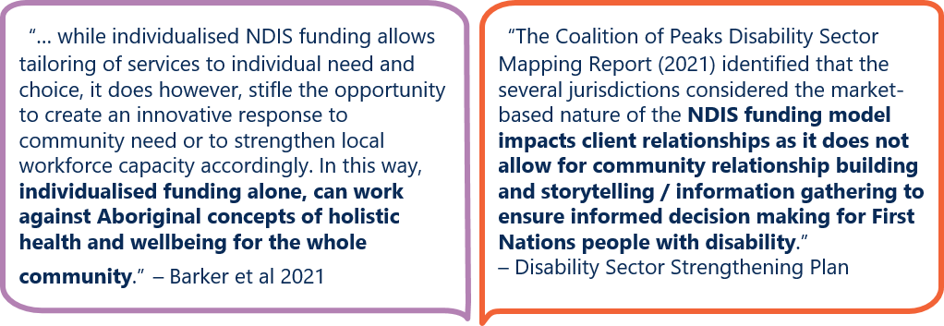
A number of ongoing initiatives are aimed at ensuring the NDIS is more culturally safe and responsive for First Nations people to access and navigate the NDIS (Box 2).
Building the cultural competency of existing NDIS providers will go some way to strengthening the responsiveness, quality, and range of services delivered to First Nations people with disability.
Priority should be to strengthen the community-controlled disability sector. Building the First Nations community-controlled sectors is one of four Priority Reform areas under the 2019 National Agreement on Closing the Gap (the Closing the Gap National Agreement). The disability sector is one of four initial sectors identified for joint national strengthening effort.
As part of this, the 2022 Disability Sector Strengthening Plan (DSSP) outlines six key areas for action to build the capacity of existing and new community-controlled disability services to deliver a full range of culturally safe and inclusive services. Key actions include localised community-led strategies, joined up service delivery and strengthening a dedicated First Nations disability workforce that embeds a cultural model of inclusion.
Investment in strengthening community-controlled disability services for all First Nations people with disability is also a priority for First Nations disability sector stakeholders.
First Peoples with Disability Network’s “National Disability Footprint” and “Ten priorities to address disability inequity” are both underpinned by building the capacity of First Nations’ community-controlled organisations and growing the First Nations disability workforce.

Box 2 Initiatives to improve First Nations participant experience
The NDIA is currently building cultural competency of NDIA staff and NDIA Partners through cultural awareness training. They are also embedding dedicated Aboriginal Disability Liaison Officers to support NDIA Partners deliver a more culturally inclusive and responsive participant experience.
Across some remote areas, NDIA has also rolled out the following elements based on each community’s needs and attributes:
Remote Community Connectors (RCC) provide culturally appropriate and locally based support in remote areas, with a focus on improving First Nations peoples’ awareness and understanding of the NDIS.
Evidence, Access and Coordination of Planning Program (EACP) help people with disability and developmental delay in remote communities to test their eligibility to access the NDIS and navigate the access process. This includes helping people with gathering evidence from mainstream services when applying to access the NDIS.
Remote Early Childhood Services (RECS) help children aged under 7 access early supports and services. This is currently a pilot program in Western Australia.
First Nations cultural brokers have also been engaged in a limited number of locations to act as a conduit between NDIA and remote First Nations communities.
Kimberley Aboriginal Medical Services (KAMS) and its consortium members have been influential in the design, development, and implementation of the RECS program across WA, including the Kimberley. This includes how this program intersects and complements the RCC and EACP programs.
During the Disability Reform Ministers meeting in October 2022, KAMS discussed and proposed the opportunity to roll out the Kimberley model to additional regional and urban areas across Australia.
Throughout 2023, the NDIA will also be co-designing a new First Nations Strategy and action plan to improve the experience and outcomes for First Nations people with disability. This will be done in formal partnership with the First Peoples Disability Network (FPDN) and guided by the First Nations Advisory Council (FNAC).
The NDIS Commission has also funded some grants to remove barriers for Aboriginal Community Controlled Organisations (ACCOs) and enhance provider capability to deliver services to First Nations Australians living in rural and remote communities.
Under the DSSP, FPDN and Western Sydney University are currently developing a Cultural Model of Inclusion Framework and Organisational Assessment Tool. This framework and assessment tool aim to improve the quality of NDIS services to be culturally safe, inclusive and disability rights informed.
Using alternative commissioning approaches, First Nations communities could commission community-controlled organisations to ensure the availability of disability supports that are responsive to their needs, particularly where the market has failed to respond.
In this way, community-driven alternative commissioning approaches can be a powerful tool to deliver culturally appropriate supports across metropolitan, rural and remote Australia.

Place-based and community-driven alternative commissioning approaches can generate more responsive and sustainable supply in remote areas
Challenges in delivering services to remote areas are well-known. These are not unique to the NDIS, but they are amplified by the current market-based model with individualised funding arrangements.
- Demand is often low, geographically dispersed and fragmented across government and non-government systems in remote areas.
- Individualised funding arrangements further fragments an already low, dispersed demand for services. They also increase demand risk – where actual demand for services is lower than the forecasted demand – since service providers are more exposed to changes in demand when a participant’s NDIS funding is reassessed.
- Service delivery costs are inherently higher in remote and very remote Australia. These costs – such as investment for capital infrastructure and travel for fly-in, fly-out (FIFO) and drive-in, drive-out (DIDO) arrangements – particularly impact providers’ financial viability since, under a market-based approach, these costs are often not shared across service providers.
- Service providers also face more pronounced logistical difficulties and more acute workforce challenges in delivering services to remote and very remote Australia.
- Prospective local providers are reluctant to register as NDIS providers due to the regulatory impost and cost. Existing First Nations community-controlled organisations are also reluctant to deliver NDIS services due to the financial risks involved and potential reputational risk with the broader community.
No one-size-fits-all approach to delivering NDIS supports will work for remote communities.
Each remote community has unique geographical considerations, demographic compositions and cultural contexts (Figure 10). For First Nations communities, connection to land, community, culture and kin also cannot be underestimated, particularly in remote Australia.
‘Social and emotional wellbeing is the foundation of physical and mental health for Indigenous Australians. It is a holistic concept that encompasses the importance of connection to land, culture, spirituality and ancestry, and how these affect the wellbeing of the individual and the community.’
– Australian Institute of Health and Welfare
- Remote and very remote communities have fundamentally different cultural contexts, and they vary widely
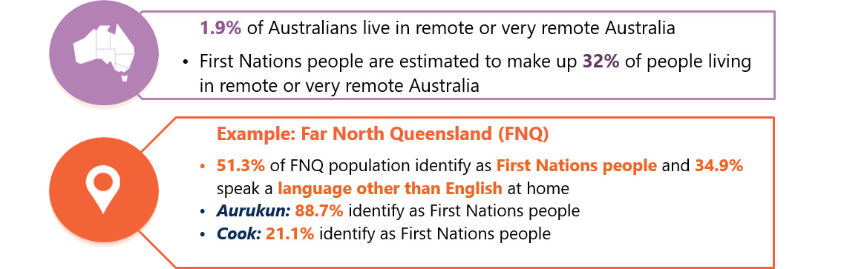
Note: Far North Queensland (Statistical Area Level 3) covers 16 local government areas (LGA).

Pricing initiatives to date go some way in addressing these challenges …
Price limits for NDIS supports have been adjusted in recognition of the costs associated with delivering supports to remote areas.
In July 2019, remote and very remote loadings have been uniformly increased from 20% and 25% to 40% and 50% respectively. From 2020 onwards, the NDIA also introduced more flexible pricing arrangements allowing for services to be delivered via other models, including via telehealth.
This has seen some improvements in access to supports. Average NDIS plan utilisation rates increased slightly in remote areas – from 63% in June 2019 to 68% in December 2022. Very remote areas have seen a larger change – increasing from
39% in June 2019 to 52% in December 2022.
Even so, participant outcomes in remote and very remote communities still lag well behind metropolitan and regional areas, which had average plan utilisation rates of over 70% in December 2021 (Figure 11).

- Uniform increases in remote and very remote loadings in NDIS price limits are not enough to address thin markets in remote and very remote areas
Price of an hour of standard care | Price June 2019 | Price Dec 2021 | Nominal increases in price, including loading (%) | Utilisation June 2019 | Utilisation December 2022 | Increase in utilisation (%)
MMM 1 | $45.54 | $57.23 | 25.7% | 69% | 76% | 7%
MMM 2 | $45.54 | $57.23 | 25.7% | 69% | 74% | 5%
MMM 3 | $45.54 | $57.23 | 25.7% | 67% | 71% | 4%
MMM 4 | $45.54 | $57.23 | 25.7% | 65% | 66% | 1%
MMM 5 | $45.54 | $57.23 | 25.7% | 58% | 68% | 10%
MMM 6 | $54.65 | $80.12 | 46.6% | 63% | 68% | 5%
MMM 7 | $56.93 | $85.85 | 50.8% | 39% | 52% | 13%

… but market gaps persist in remote and very remote communities
Applying a market-based approach to deliver high quality supports to, and outcomes for, NDIS participants in remote and very remote communities is not working.
Persistent market gaps remain through many remote and very remote communities. In December 2022, recorded market gaps were around 14% for remote participants and 27% for very remote participants. This means that utilisation of supports by remote and very remote participants is 14% and 27% lower compared with median utilisation rate for participants in the scheme for over two years receiving face-to-face supports from registered providers.
These averages also conceal the severity of market gaps across remote Australia, with a number of locations experiencing market gaps of over 40% in 2022 (Figure 12).
In remote and very remote areas, the severity of market gaps may mean some participants could be trading off their ability to remain in their community against their access to supports. Often there is a greater need for local, culturally safe supports to be delivered to First Nations participants in remote areas, but First Nations organisations can be reluctant to become NDIS providers due to the regulatory impost and reputational risks involved.
“Many [First Nations] people were born in remote communities and due to their high level support needs had no other option but to relocate to urban areas to access essential supports.”
– Somerville Community Services

- Remote and very remote Australia have greater share, severity and persistence in NDIS market gaps
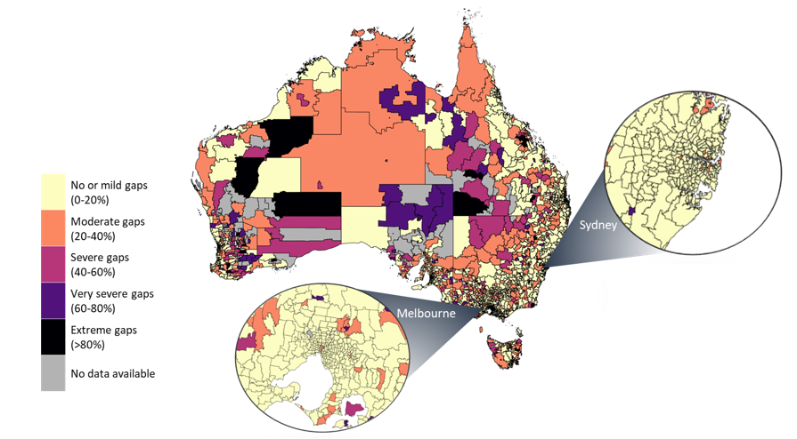
Notes:
- Market gaps were calculated for participants in the scheme for two or more years. Utilisation rates were compared for participants residing in each postcode with the national median plan utilisation.
- Postcodes were used to calculate market gaps rather than larger Local Government Areas (LGAs) since LGAs can span multiple remoteness categories.
- Pop-out maps showing the greater Sydney and Melbourne areas are provided as examples of market gaps in major cities.
- This data is at 31 December 2022 and excludes in-kind supports.
Even where participants are getting services, many of these services rely heavily on FIFO and DIDO arrangements rather than local, on-the-ground solutions.
…there is a reliance on fly-in fly-out (FIFO) and drive-in drive out (DIDO) arrangements to provide services in these communities. This is very expensive, represents little value for money, and may also not be the best for the participants.
– NACCHO 2021
Where they are concerned about the safety and quality of available services (including cultural safety), participants often have little recourse to find safer or better quality services due to low market competition within these communities (Figure 13).
Moving to place-based and community-driven alternative commissioning approaches can offer opportunities to create more holistic and sustainable, local services and create sustainable jobs in remote communities.
- In remote communities, the NDIS market for core supports is 7 to 10 times more concentrated, and 7.5 to 15 times more concentrated for capacity building supports compared to non-remote areas
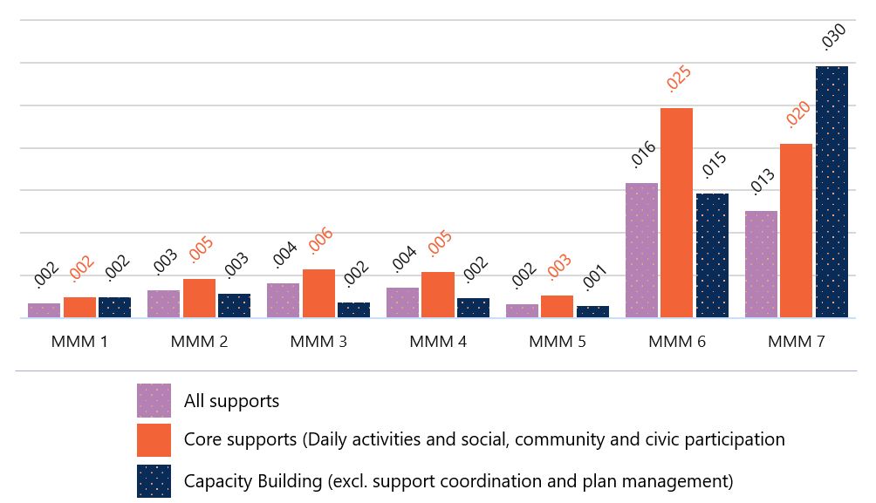
Note: Market concentration by remoteness is calculated using the Herfindahl-Hirschman Index (HHI), and is based on registered and unregistered providers paid during 1 January to 30 September 2022. Visibility of unregistered providers depends on capture of Australian Business Numbers (ABNs) by plan managers. It excludes claims for self-managed supports.
Figure 13 text description

Alternative commissioning can lower demand risk and costs for communities
In failing to deliver safe, quality and timely supports and outcomes for participants in remote communities and in First Nations communities, the current market-based model also drive poor outcomes and upward pressures on the long term costs of the NDIS for these participants.
Failing to deliver participant outcomes in these communities also puts pressure on the entire care and support ecosystem. A lack of timely supports may lead to increased hospitalisation rates or lengthier hospital stays, which in turn increases pressure on the primary healthcare system.
Alternative commissioning approaches provide opportunity to:
- Lower the cost of service delivery by offering service providers greater certainty of demand to invest in more effective service delivery models – this includes models that better coordinate and target investment in building and maintaining community infrastructure. Existing initiatives (including those by non-profit organisations, local, state or territory and Commonwealth governments) can be leveraged and built upon, while new initiatives could be better targeted where need is most pressing. More effective service delivery models could also strengthen investment in local workforce and rely less on costly and ineffective FIFO and DIDO models.
- Improve health and wellbeing outcomes for both First Nations and remote communities using a more holistic, lifetime-based approach – for example, the FNQ Connect (Case Study 2) noted ‘Improving integration of care and support will improve quality of life and health outcomes which will lead to a reduction in potentially preventable hospitalisations (PPH) and reduced pressure on the hospital sector over the medium-to-long term’.
As outlined in the Closing the Gap National Agreement, better life outcomes are also achieved when First Nations people have a genuine say in the how services are designed and delivered.

Finding 2 Alternative commissioning approaches for both First Nations and remote communities
While increases in remote and very remote price loadings and more flexible pricing arrangements (to cover telehealth) have addressed some challenges in these areas, persistent market gaps remain. Addressing market gaps for remote communities and First Nations community-controlled organisations will require a different market approach that can better coordinate supports.
Alternative commissioning approaches that are placed-based and community-driven could strengthen the First Nations community-controlled disability sector and build sustainable supply of NDIS services in remote areas.
These approaches could lower the cost of service delivery by offering service providers greater certainty of demand. This could also increase their ability to achieve scale and continuity of supply.
Alternative commissioning arrangements would enable culturally appropriate supports to be delivered by a more localised workforce. These approaches could also improve outcomes for participants and drive a more sustainable care and support ecosystem over time.

Implementing a placed-based, community-driven alternative commissioning approach
To be effective in improving service delivery for both First Nations communities and remote communities, alternative commissioning needs to follow a commissioning cycle (Figure 14). The cycle involves:
- understanding communities’ strengths and needs, including what initiatives and infrastructure already exist on the ground and can be built upon
- exploring and designing solutions from the ground up based on local needs and priorities
- implementing the approach by selecting, overseeing, and engaging with providers and managing contracts. Implementation should also consider complementary policy or ‘enablers’, including: the role of intermediary supports, regulatory settings for ensuring appropriate quality and safeguarding, and pathways to access services
- ongoing monitoring, evaluation, and improvement.
- Building blocks for alternative commissioning
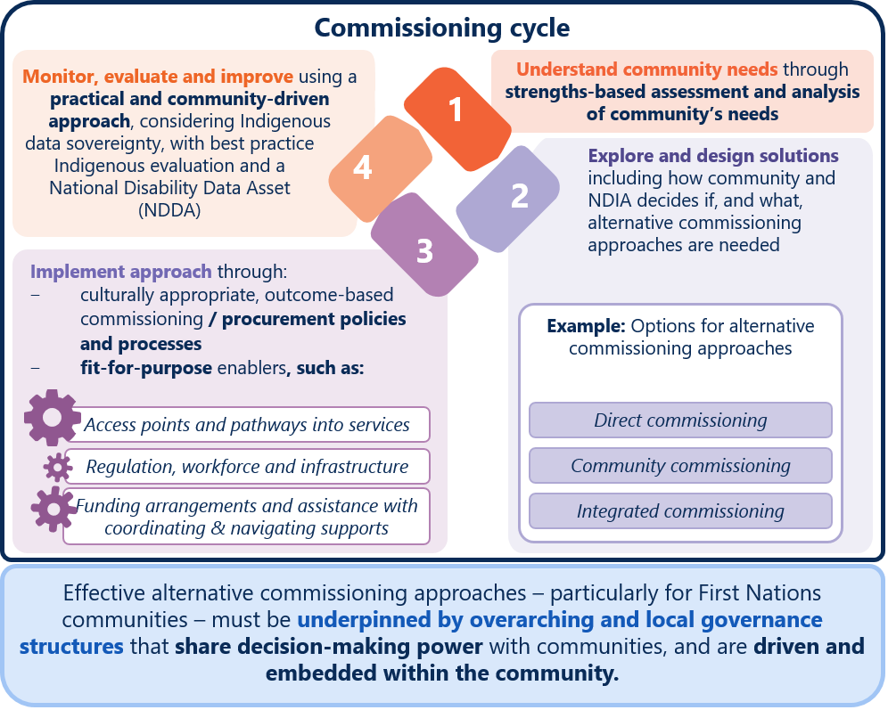
Figure 14 text description

There are a range of alternative commissioning approaches
As noted above, alternative commissioning approaches are not returning to ‘block funding’. Instead, they should provide participants – particularly those living in remote and very remote areas – with better continuity of services while offering choice and control over which service delivery model best suits the needs of the local community.
Alternative commissioning approaches could be designed to coordinate demand for a number of NDIS supports within the community. Participants could flexibly access what they need, when they need. Design options could aim to set service providers up to deliver supports responsively to local needs and sustainably over the long term.
Alternative commissioning approaches could also be designed to coordinate demand for care and supports across disability supports (both funded by NDIS and other governments), health, aged care and veterans’ care supports.
Rather than separately funding different supports and community capacity building initiatives, funding for services could be more coordinated (or ‘integrated’) across programs to minimise duplication and gaps.
Services in remote Indigenous communities are often poorly planned and uncoordinated, both between and within governments, and between service providers. Decisions about service provision are made on the basis of jurisdictional, departmental and program boundaries, and this may come at the expense of a focus on outcomes for users.
Integrated commissioning approaches would make it clearer and easier for communities – particularly in remote areas – to understand what services they can access, from who and when.
Having a single interface point for services such as disability support, aged care and veterans’ care supports can provide better wrap-around supports and services with smoother transitions across different life stages. For example, the Far North Queensland Connect: Connecting people, connecting care (FNQ Connect) proposes developing a joint funding mechanism to align resources (Case Study 2).
For potential and existing service providers, integrated commissioning approaches may make it easier to achieve scale and reduce demand risk across the various care and supports needed in the community. Design of the enablers for alternative commissioning approaches (Figure 15) may also make it easier for service providers to deliver supports in the community by reducing the complexity in different care and support program approaches.
Communities could also drive the design and lead the commissioning process for the supports they need. Community commissioning approaches could use different commissioning approaches, such as integrated commissioning.

Case Study 2 Far North Queensland (FNQ) Connect – a community-driven proposal for integrated care to address low and fragmented supply
FNQ Connect: connecting people, connecting care is a proposed model for disability, rehabilitation and lifestyle services for children, young people, adults and older people.
The FNQ Connect proposes to integrate and strengthen existing services in the 21 Local Government Areas which make up FNQ. The proposed models includes a network of community hubs that act as a ‘one-stop-shop’ for community rehabilitation services, information, education, and advocacy. The proposed hubs’ activities include:
- connecting care and support through shared health records, shared clinical governance and expansion of transition and navigation service
- strengthening local community workforce and locally owned services through the development of certified workforce pathways and sustainable local services to match local needs
- building inclusive communities through inclusive policies, procedures, education and investment.
FNQ Connect is proposed to be an independent entity, guided by a Leadership Table led by people with lived experience of disability and representatives of Aboriginal and Torres Strait Islander communities, senior executives from key FNQ government, non-government and private stakeholder organisations. The Leadership Table will begin by developing a joint funding mechanism to leverage existing capacity and assets of agencies within FNQ Connect.

Approaches need to be underpinned by strong partnerships
The most critical element of this cycle is governance structures that share decision-making power with First Nations representatives and communities. This has been agreed to in the Closing the Gap National Agreement, endorsed by all jurisdictions.

Closing the Gap National Agreement
The Closing the Gap National Agreement commits all Australian governments to work in full and genuine partnership with First Nations people in making policies to close the gap.
In exploring alternative commissioning approaches with communities, governments should ensure they continue to work in partnership with First Nations people and give effect to the four Priority Reforms (Figure 15).
The NDIA is taking important steps towards building genuine partnerships with First Nations representatives and peoples (Box 2). However, it will take time for the NDIA to build these partnerships.
- Governments must work in partnership to roll out alternative commissioning approaches that deliver against the four Priority Reforms in the Closing the Gap National Agreement
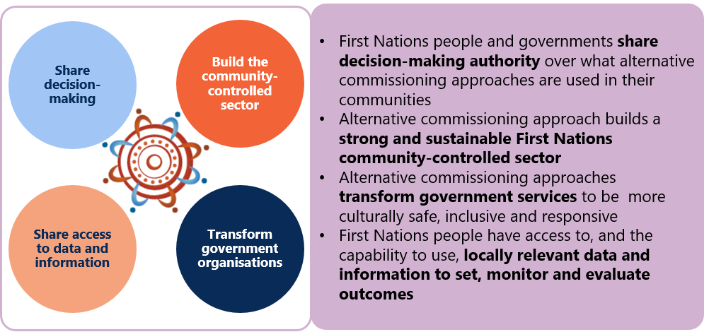
Strong partnerships will be necessary among communities, local First Nations organisations and experienced disability service providers. They will need to build each other’s knowledge and understanding of disability, culturally appropriate ways of doing business and the individual community context. Time will also be needed for potential providers to build capacity and capability to respond to the participants’ needs.

The Disability Sector Strengthening Plan
The DSSP also provides a framework of engaging with and responding to the needs of First Nations people with disability. All jurisdictions committed to the Guiding Principles (Figure 16) as a set of minimum standards when developing policies, programs, services and systems for First Nations Peoples with disability.
Alternative commissioning approaches aligned with DSSP action to implement localised community-led strategies to respond to NDIS thin markets. These DSSP action include investing in the community-controlled sector to design and implement place-based approaches that address thin markets across Australia. The DSSP also outlines actions to facilitate a process for community-controlled organisations to provide NDIS services.
- The 12 Guiding Principles in the Disability Sector Strengthening Plan.
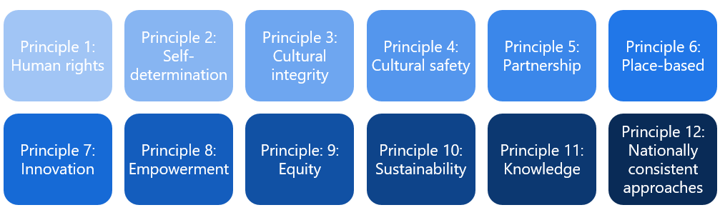

The timing of roll out should be community-led
Expanding new approaches in remote communities too far, too fast is a significant risk.
Roll out should also be on a case-by-case basis, depending on each community’s capacity and capability. For example, community commissioning approaches (Figure 5) should draw on a community’s capacity at the time to lead the alternative commissioning approach.
First Nations communities in non-remote areas should have the option choose whether alternative commissioning approaches could better deliver culturally appropriate NDIS supports to meet their needs.
Learnings and experience to date from the NDIS thin market trials also indicate that NDIA needs to build their capacity and capability to roll out alternative commissioning approaches. Part of building NDIA’s capability will be to ensure a sound foundation (or ‘building blocks’) for alternative commissioning (Figure 14).
Commencing alternative commissioning pilots as soon as possible will help to understand what works and allow time to develop and strengthen partnerships with communities. An evaluation of these pilots should inform how to progress the full roll out of alternative commissioning. The evaluation should also review the extent to which integrated commissioning approaches are preferred by both First Nations and remote communities and how they can improve outcomes for participants in these communities.

Recommendation 1
Working in partnership with First Nations representatives and
remote communities to roll out alternative commissioning approaches
The NDIA should partner with First Nations representatives, communities, participants and other government agencies to progressively roll out alternative commissioning arrangements for both First Nations communities and remote communities, starting as soon as possible.
The alternative commissioning approaches should be designed in partnership with First Nations representatives, communities and participants, and should be:
underpinned by governance structures that share decision-making power with communities – including First Nations representatives in non-remote communities as well as remote community representatives (which also encompasses the non-Indigenous local population)
based on a commissioning cycle that:
- is underpinned by an understanding of community strengths and preferences
- explores and designs commissioning approaches on a case-by-case basis with communities. This could include models of direct and community-led commissioning approaches as well as integrated commissioning (where a provider is commissioned to provide supports across multiple services types)
- provides culturally appropriate, outcome-based commissioning processes and enablers, and
- uses practical and community-driven processes to collect data and evaluate outcomes.
A progressive roll out of alternative commissioning approaches should commence with pilots in selected communities. Pilots should be evaluated in partnership with communities.
The evaluation should inform the wider roll out of alternative commissioning by drawing out lessons on how to build the capability of communities and governments as commissioners and the types of alternative commissioning approaches that work best. This should include considering the effectiveness of integrating commissioning for remote participants.
Over time, communities should be supported to buy and coordinate the supports for themselves. Communities would design the approach and lead the commissioning process.

5. Next steps

The Review will leverage existing relationships with both First Nations and remote communities to design the elements and enablers of alternative commissioning approaches.
The NDIS Review will provide initial support and guidance to governments and the NDIA to help build capacity to progressively roll out alternative commissioning approaches.
- Throughout 2023, we will work in partnership with governments, First Nations representatives and communities to design the elements and enablers of the alternative commissioning cycle and work with the NDIA to start some pilots in selected communities (Figure 14)
- We will leverage the existing engagement and relationships that the NDIA has with First Nations representatives and communities to ensure partnerships continue after the NDIS Review.
- At the end of the Review, the NDIA would continue working in partnership with First Nations communities and remote communities who contributed to the design of the alternative commissioning cycle. Depending on the preferences of specific communities, this could include continuing work to progress further alternative commissioning pilots.

The Review will also continue to consult on other market challenges
As outlined above, a range of other market challenges exists across the NDIS and a more active and flexible role for governments as stewards of the NDIS market is needed to address persistent market challenges.
We will explore and consult on how to build on the learnings of the recent NDIS thin market trials to consider how market coordination tools and other market mechanisms could be applied and scaled up in the NDIS.

Appendix 1 – Text descriptions

Figure 1 - Quotes from past reviews and inquiries about challenges in NDIS market
Figure 1 has 6 speech bubbles outlining key challenges in the NDIS market.
Six key challenges have been highlighted in past reviews of the NDIS, and are still issues in the current NDIS.
These include:
- Limited access to supports in remote and very remote areas
- Lack of culturally appropriate care for First Nations communities
- Shortages of some supports in non-remote communities, particularly specialised services
- Some participants (with complex needs) are being left behind
- Limited capability of NDIA to identify thin markets
- Unclear protection of participants against market failure.
Return to Figure 1

Figure 2 - Data on mature participants who at still not accessing the supports they need
Mature participants are those who have been in NDIS for over a year.
The following percentage of mature participants had a budget for daily activity supports but did not claim any supports during 1 July 2022 to 30 September:
- 23% in metropolitan areas
- 26% in regional areas
- 34% in remote areas
- 36% in very remote areas.
The following percentage of mature participants had a budget for therapy supports but did not claim any supports during 1 July 2022 to 30 September:
- 24% in metropolitan areas
- 31% in regional areas
- 32% in remote areas
- 37% in very remote areas.
Return to Figure 2

Figure 4 - Key characteristics for designing effective delivery approaches for social services
Participant characteristics include:
- Capability of participants to make informed choices
- Complexity of participant's support needs
- Where and how participants want to live
Nature of supports include:
- importance of trusting providers
- importance of cultural safety
- costs to find or switch providers
- predictability, frequency, timing of support needs
- interdependent supports or possibilitiy to bundle.
Characteristics of service providers include:
- scope for multiple providers or service options to exist in the market
- capacity to monitor provider performance
- synergies and opportunities in broader care and support sector or other sectors
- barriers or incentivies to enter, grow, shrink or exit the market
- workforce capacity and capabilty.
Return to Figure 4

Figure 5 - Outline of NDIS Market Stewardship tools
A range of market tools that can be used in NDIS markets to ensure effective delivery of supports:
Level 1: Competition in the market can deliver strong incentives for providers to be more focused on participants' needs.
Level 1.1: Market coordination tools include:
- Market facilitation - engagement and information sharing to improve participant and provider connection
- Intermediaries - someone to help participant find and connect with services.
- Market deepening - participant can pool funding and coordinate demand to attract providers.
Level 1.2: Market settings include: pricing and payment approaches and market access settings (e.g. who can enter in the market).
Level 2: Contestable arrangements drives competition for the market. It can ensure a provider faces a credible threat of replacement if it underperforms, where competition between multiple providers is not possible.
Level 2.1: Alternative commissioning includes:
- Direct commissioning - where supports are directly purchased on behalf of a group of participants. Supports can be purchased from non-government or government providers – who should ideally be separate from the funding body to ensure a level playing field.
- Integrated commissioning - involves selecting a provider to provide supports across multiple services types for a defined area. What services types are commissioned and how they are delivered is based on identified community needs.
- Community commissioning - is where communities are empowered, or use cooperative approaches, to lead the commissioning process. Communities, rather than governments, determine the services and providers that best meet their needs. Community commissioning may be implemented using direct or integrated commissioning.
Level 2.2: Provider of last resort arrangements help to maintain continuity of service when a provider cannot deliver services to some or all users. Governments can coordinate other providers to take on users, bail out a failing provider, increase funding to the provider, identify other providers, or directly provide the service.
Return to Figure 5

Figure 7 - Timeline representation of alternative funding and alternative commissioning approaches recommendations
A timeline outlining relevant recommendations from 2017 onwards.
2017 Productivity report on NDIS costs suggests a tailored response to NDIS thin markets.
2018 Joint Standing Committee on the NDIS Inquiry (JSC NDIS) into Transitional Arrangements suggested exploring alternative funding models. NDIA & DSS commenced development on the NDIS Thin Market Approach
2019 relates to JSC NDIS recommends testing approaches other than 'fee-for-service'; NDIS thin Markets Framework developed; Tune Review recommended more defined powers for NDIA to intervene in markets.
In 2020, Disability Reform Council agreed to a more flexible approach to thin markets; NDIA began Thin Market Trials.
In 2021 Queensland Productivity Commission Inquiry on the NDIS Market in Queensland recommended alternative commissioning.
By end of 2022, 39 NDIS Thin Market Trials are completed or underway across Australia.
Return to Figure 7

Figure 13 - Graph of NDIS market support concentration in relation to Modified Monash Model
Bar graph looking at market concentration using the Herfindahl-Hirschman Index (HHI), for different groups of supports and by remoteness.
HHI for all supports: ranges from 0.002 to 0.004 in metropolitan, regional and rural areas; rises to 0.016 in remote areas, and 0.013 in very remote areas.
HHI for daily activities and social, community and civic participation supports: ranges from 0.002 to 0.006 in metropolitan, regional and rural areas; rises to 0.025 in remote areas, and 0.020 in very remote areas.
HHI for capacity building supports (excluding support coordination and plan management): ranges from 0.002 to 0.003 in metropolitan, regional and rural areas; rises to 0.015 in remote areas, and 0.030 in very remote areas.
Return to Figure 13

Figure 14 - Commissioning cycle
A 4 stage cycle where:
Stage 1 relates to understanding community needs through strengths-based assessment and analysis of community’s needs.
Stage 2 relates to exploring and designing solutions. This includes how community and NDIA decides if, and what, alternative commissioning approaches are needed - such as direct commissioning, intergrated commissioning and community commissioning.
Stage 3 is implementing the alternative commissioning approach through: culturally appropriate, outcome-based commissioning. procurement policies and processes; and fit for purpose enablers.
Stage 4 is about monitoring, evaluating and improving through a practical and community-driven approach. This needs to consider Indigenous data sovereignty, with best practice Indigenous evaluation and a National Disability Data Asset (NDDA)
Throughout the cycle, effective alternative commissioning approaches – particularly for First Nations communities – must be underpinned by overarching and local governance structures that share decision-making power with communities, and are driven and embedded within the community.
Return to Figure 14

National Disability Insurance Agency (NDIA), NDIS quarterly report to Disability Ministers for Q2 of 2022-23 financial year, NDIA website, 10 February 2023, https://www.ndis.gov.au/about-us/publications/quarterly-reports
Productivity Commission (PC) 2017, National Disability Insurance scheme (NDIS) Costs – Study Report, PC website, 19 October 2017, https://www.pc.gov.au/inquiries/completed/ndis-costs
PC, NDIS Costs – Study Report; Joint Standing Committee on the National Disability Insurance scheme, Market Readiness for provision of services under the NDIS - Final Report, 20 September 2018, pp.63-78 https://www.aph.gov.au/Parliamentary_Business/Committees/Joint/National_Disability_Insurance_scheme/MarketReadiness/Report; Joint Standing Committee on the NDIS, NDIS Planning Final Report, 1 December 2020 pp. 173-176, 201-211, https://www.aph.gov.au/Parliamentary_Business/Committees/Joint/National_Disability_Insurance_scheme/NDISPlanning/Final_Report; Joint Standing Committee on the NDIS, NDIS Workforce Final Report, 15 February 2022, pp.23-31, 37-50, https://www.aph.gov.au/Parliamentary_Business/Committees/Joint/National_Disability_Insurance_scheme/workforce; D Tune, Review of the National Disability Insurance scheme Act 2013 Report, December 2019, accessed 21 December 2022, https://www.dss.gov.au/disability-and-carers-programs-services-for-people-with-disability-national-disability-insurance-scheme/review-of-the-ndis-act-report; Joint Standing Committee on the NDIS, General issues 2021, 30 November 2021, pp.122, https://www.aph.gov.au/Parliamentary_Business/Committees/Joint/National_Disability_Insurance_scheme/GeneralIssues/Report_2021; Queensland Productivity Commission (QPC), Inquiry into The NDIS Market in Queensland Final Report, April 2021, pp.256, https://www.treasury.qld.gov.au/queenslands-economy/office-of-productivity-and-red-tape-reduction/former-queensland-productivity-commission/
Department of Social Services (DSS), Analysis on NDIS monthly data sets as at 31 December 2022, unpublished, accessed March 2023
PC, NDIS Costs – Study Report; Joint Standing Committee on the National Disability Insurance scheme, Market Readiness for provision of services under the NDIS - Final Report, pp.3-78
Ernst and Young, NDIS Thin Markets Project – Approach to Thin Market – Final Report, December 2019, unpublished
Disability Reform Council, Meeting of the COAG Disability Reform Council Communique, 13 December 2019, DSS website, https://webarchive.nla.gov.au/awa/20220604013729/https://www.dss.gov.au/disability-and-carers-programs-services-government-international-disability-reform-council/communique-13-december-2019
NDIA, Thin Market Trials Evaluation – Final Report, unpublished, accessed January 2023
NPY Women’s Council, Response to Alternative commissioning for remote and First Nations communities, unpublished, accessed April 2023
NPY Women’s Council, Response to Alternative commissioning for remote and First Nations communities
Joint Standing Committee on the NDIS, NDIS Workforce Final Report, pp.23-31; QPC, Inquiry into The NDIS Market in Queensland Final Report, p.147-163
NDIA, Thin Market Trials Evaluation – Final Report, unpublished, accessed January 2023
NDIA, Thin Market Trials Evaluation – Final Report
NDIA, National Remote Services Branch presentation to NDIS Review, unpublished, accessed December 2022
D Reeders, G Carey, E Malbon, H Dickinson, D Gilchrist, G Duff, S Chand, A Kavanagh, & D Alexander 2019, Market Capacity Framework: An approach for identifying thin markets in the NDIS, December 2019, Centre for Social Impact: Sydney, https://www.csi.edu.au/research/market-capacity-framework-an-approach-for-identifying-thin-markets-in-the-ndis/
D Tune, Review of the National Disability Insurance scheme Act 2013 Report, pp.123
Productivity Commission (PC) 2017, National Disability Insurance scheme (NDIS) Costs – Study Report; D Tune, Review of the National Disability Insurance scheme Act 2013 Report, pp.56-57
Joint Council on Closing the Gap, Disability Sector Strengthening Plan (DSSP), 26 August 2022, Closing the Gap website, pp. 28, accessed 11 January 2023, https://www.closingthegap.gov.au/resources
NDIA, NDIS quarterly report to Disability Ministers for Q2 of 2022-23 financial year
NDIA, National Remote Services Branch presentation to NDIS Review
Joint Standing Committee on the NDIS, NDIS Planning Final Report, pp.174
Joint Standing Committee on the NDIS, NDIS Planning Final Report, pp. 202
QPC, Inquiry into The NDIS Market in Queensland Final Report, pp.378
Melbourne Disability Institute (MDI), Commonwealth Study into NDIS Plan Utilisation Synthesis Report, June 2021, https://disability.unimelb.edu.au/home/projects/collaborative-research/ndis-plan-utilisation
Joint Standing Committee on the NDIS, NDIS Planning Final Report, pp.174
NDIA, Number of indigenous, registered providers as at December 2022, n.d. (unpublished)
R Barker, K Bird, I Bohanna, F Thompson, K Lawson, L Blanco, L Mick-Ramsamy, L Harriss, J McLucas, M McDonald, J Cullen, H Wapau, S Forbes, A Wason, and E Strivens, FNQ Connect: Connecting people connecting care. A proposal for reform of Far North Queensland Disability, Rehabilitation and Lifestyle Services for children, young people, adults and older people 2022 – 2027, James Cook University, Cairns, pp.17, https://researchonline.jcu.edu.au/72985/; Joint Council on Closing the Gap, Disability Sector Strengthening Plan (DSSP), pp.29
Joint Council on Closing the Gap, DSSP
NDIA, NDIS in Remote Programs, 2022, n.d (unpublished)
KimberleySupports, Building a Stronger NDIS Together – presentation to Disability Reform Ministers’ Meeting on 13 October 2022, unpublished, accessed December 2022
QPC, Service delivery in remote and discrete Aboriginal and Torres Strait Islander communities Final Report, December 2017, https://www.dsdsatsip.qld.gov.au/our-work/aboriginal-torres-strait-islander-partnerships/discrete-remote-communities/queensland-productivity-commission-service-delivery-inquiry; PC, Indigenous Evaluation Strategy, 30 October 2020, p.80-81, https://www.pc.gov.au/inquiries/completed/indigenous-evaluation#report
QPC, Inquiry into The NDIS Market in Queensland Final Report, pp.380
PC, Introducing Competition and Informed User Choice into Human Services: Reforms to Human Services Inquiry Report, 26 March 2018, pp.268, https://www.pc.gov.au/inquiries/completed/human-services/reforms/report; McKinsey & Company, Independent Pricing Review, National Disability Insurance Agency: Final Report, February 2018, NDIA website, accessed 11 January 2023, https://www.ndis.gov.au/providers/pricing-arrangements/making-pricing-decisions/pricing-review-archive
QPC, Inquiry into The NDIS Market in Queensland Final Report, pp.385, 395-6
QPC, Inquiry into The NDIS Market in Queensland Final Report, pp.380-1
QPC, Inquiry into The NDIS Market in Queensland Final Report, pp.383-6
National Aboriginal Community Controlled Health Organisation (NACCHO), Submission to the NDIS Annual Price Review 2021-22, NACCHO website, accessed 11 January 2023, www.naccho.org.au/app/uploads/2022/04/NACCHO-NDIS-Pricing-Review-2021-22-.pdf, pp.6-7
Australian Institute of Health and Welfare (AIHW), Indigenous health and wellbeing, July 2022, AIHW website, accessed 6 January 2023, www.aihw.gov.au/reports/australias-health/indigenous-health-and-wellbeing
AIHW, Rural and remote health, July 2022, AIHW website, viewed 5 January 2023, www.aihw.gov.au/reports/rural-remote-australians/rural-and-remote-health Australian Bureau of Statistics (ABS), Region summary: Far North, ABS website, 2021, accessed 6 January 2023; ABS, Region summary: Cook, ABS website, 2021, accessed 6 January 2023; ABS, Region summary: Aurukun, ABS website, 2021, accessed 6 January 2023;
NDIA, NDIS WA Market Review Final Report, NDIS website, 1 July 2019, pp.54-63
NDIA, Annual Pricing Review 2021-22 Final Report, 22 June 2022, pp.165-178
NDIA, Annual Pricing Review 2021-22 Final Report, pp.175-176; NDIA, December 2022 update, published, accessed February 2023
DSS, Quarterly NDIS market key performance indicator report for Q2 FY2022-23, unpublished, accessed March 2023
JSC, General issues around the implementation and performance of the NDIS, Final Report, February 2019, pp. 43-51
DSS, Analysis on NDIS monthly datasets, unpublished, accessed March 2023
NACCHO, Submission to the NDIS Annual Price Review 2021-22
DSS, Thin markets data request for NDIS Review, unpublished, accessed March 2023
PC, NDIS Costs – Study Report, pp. 270
R Barker. et al., FNQ Connect: Connecting people connecting care. A proposal for reform of Far North Queensland Disability, Rehabilitation and Lifestyle Services for children
This includes the 16 LGAs in the Far North SA3 (Figure 10), as well as 5 other LGAs: Cairns Regional, Cassowary Coast Regional, Douglas Shire, Tablelands Regional and Yarrabah Aboriginal Shire.
PC, NDIS Costs – Study Report, pp.29-30

