Building a more responsive and supportive workforce
  - May 2023

Contents

Overview 2
Key points 4
1. Building the future NDIS workforce 5
2. Workforce challenges are well known and widespread 9
3. Pathways and advancement in the care and support sector 14
Supporting workers to remain and advance in the care and support sector 14
Strengthening pathways into the sector 21
Targeted migration can help fill acute workforce gaps 25
Better sector-wide workforce planning 26
4. NDIS quality and safeguarding – workforce requirements 29
5. NDIS market settings 33
Next steps 34
Appendix 1: Alternative text 35

Overview
Over the past seven years, the NDIS workforce has more than doubled. Today some 325,000 workers across a diverse range of occupations and settings support NDIS participants, their families and carers.
The essential care and support provided by these workers throughout the COVID-19 pandemic has been critical. The strain of the past few years has no doubt been felt by many NDIS workers. This strain, however, goes beyond the impacts of the pandemic to the key challenges facing the NDIS workforce.
Many NDIS workers are feeling burnt out. Jobs can be short term with high turnover, with poor conditions and poor career prospects. Workers appear to be leaving NDIS jobs at a faster rate compared to the wider economy. Providers report difficulty finding and keeping skilled and capable workers to effectively support participants. These issues are further compounded for First Nations and remote communities.
As the scheme matures, there is mounting pressure to attract more workers. Within the next three years to June 2025, an additional 128,000 workers will be needed to fully meet demand.
Efforts are needed to improve worker attraction and retention in the NDIS.
The NDIS workforce, however, does not operate independently from the wider care and support sector (disability, aged care, and veterans’ care). Meeting future NDIS workforce needs are unlikely to be achieved without significant action by governments to increase and strengthen the overall care and support workforce. As major funders of care and support services, governments reap the rewards from investing in sector-wide initiatives to attract a larger workforce. Governments also share in the dividends from building a more capable care and support workforce.
Few workers in the sector work in traditional full-time ongoing employment and many work multiple jobs. Training systems, regulation and market settings, however, are not well set-up to support ongoing learning and career development for workers in non-traditional jobs. Employers currently face little incentive to invest in training workers.
Governments need to look at modern approaches – where workers are supported and rewarded for staying in the sector and for building their skills progressively, without requiring them to stay in the same role. Schemes that allow for portability of training and sick and carer’s leave entitlements could be a way to do this. But these schemes need to be tested to ensure that workers, employers and ultimately participants and clients, benefit.
Governments must recognise the critical role people with lived experience – or peer workers – perform and do more to build the number of peer workers in the NDIS. This will not only improve outcomes for people with disability but also improve the quality of support provided. We will continue to examine ways to better support peer workers.
When combined with other actions to improve workforce attraction and retention, flexible pathways for migrants can also be part of the solution. Industry labour agreements can potentially offer a flexible pathway to address short-term workforce gaps targeted to workers with suitable skills, values and attitudes.
For governments to see the dividends of the proposed new sector-level approaches, ongoing governance and accountability is needed to ensure a joined-up approach that is lasting. The recently established Care and Support Economy Taskforce would be well-placed to take on this role initially and to push forward on sector-wide workforce initiatives.
Moving the dial on workforce challenges in the NDIS will also require a look at how the scheme is set-up and operating.
Past reviews have heard from participants, workers, and providers about the complex relationship between regulation and market arrangements – which shape entry to the NDIS workforce, training outcomes and the quality of supports provided. For example, allied health professionals have raised that the additional regulatory and administrative requirements of the NDIS may act as a disincentive to providing services.
The current arrangements are too often failing to provide quality supports or quality jobs.
Over the course of the NDIS Review we will continue to consider how regulation and market settings (including, pricing and payment settings) can better deliver outcomes for participants and governments while supporting and valuing the contribution of workers to the Scheme.
This will include looking at ways to improve market arrangements and support greater investment in capacity building, assistive technology and home modification supports. By reducing reliance on ongoing core supports delivered directly by workers, this could improve outcomes for participants and help reduce growing pressure on the workforce.
Ahead of this work, there are some practical actions that should be undertaken now to streamline worker screening checks and smooth entry pathways for workers.

Key points
- To fully meet demand, the NDIS workforce is forecast to need to grow by 40%, or 128,000 workers, over the next three years to June 2025.
- Demand is also growing across the wider sector – disability, aged care, and veterans’ care. By 2049-50, demand for care and support workers is projected to double – at which point almost 1 in 20 jobs are expected to be in the sector.
- Developing a workforce of sufficient size and capability with appropriate attitudes to meet growing demand is critical to the effectiveness and sustainability of the care and support sector. However, care and support jobs can be short term, with variable hours, high turnover, poor conditions and poor career prospects. A relatively high share of workers work multiple jobs and employers face little incentive to upskill their workers.
- Efforts to improve worker attraction and retention would support career pathways and the quality of supports, lower turnover and associated costs to service delivery.
- New approaches to training and leave could reward workers for staying in the sector and building their skills, without being required to stay in the same job.
- Schemes that allow for portability of training and sick and carer’s leave entitlements could be a way to do this. But these schemes need to be tested to ensure that they deliver overall benefits and are not unduly burdensome.
- This would complement the progression of micro-credentials (short courses or competencies), a digital skills passport and growing the use of traineeships.
- Peer workers are a critical, but underutilised, part of the sector. More must be done to increase the representation of people with disability in the workforce.
- Policy approaches to strengthening pathways into the sector are also needed. Industry labour agreements are one tool that can respond to acute labour shortages and be targeted to workers with suitable skills, values and attitudes.
- Regulation and market arrangements that govern the NDIS also shape the behaviour of providers and how workers are engaged in the Scheme. The Review is examining how these arrangements can be adapted to strengthen the workforce, quality of supports and the relationship between participants and workers.
- In the meantime, priority should be given to streamlining current operational issues with NDIS worker screening checks – where the median time to process worker screening applications takes up to 11 business days in some jurisdictions, and beyond if the time for workers to lodge their application and have their identity verified is also counted.

Building the future NDIS workforce
The NDIS workforce, working across registered and unregistered providers, has grown and evolved through the scheme’s transition phase. On a full-time equivalent basis, the NDIS workforce has grown from around 74,000 in June 2015 to 202,000 in 2021-22. The actual number of Australians supporting participants is much higher still at around 325,000 in 2021-22 (Figure 1).
Informal carers also play an invaluable role in supporting people with disability. This paper, however, is focused on building a more responsive and supportive formal workforce.
- The NDIS workforce is diverse, covering disability support workers, allied health workers and other workers working across a variety of settings
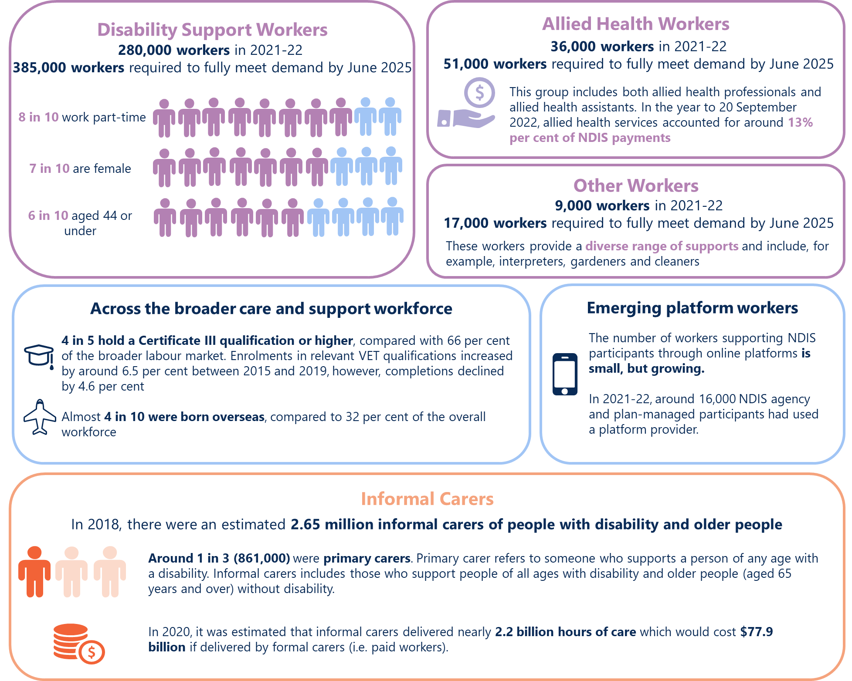
Text description of Figure 1
Despite this growth, large and persistent workforce shortages remain in the NDIS under current policy settings. This limits access to suitable supports for some participants and places pressure on existing workers, particularly in regional and remote areas and for some participant groups.
What’s more, an additional 128,000 workers are forecast to be required by June 2025.
Unless the high level of turnover can be addressed, the number of new workers who need to enter the NDIS will be higher still. In a given year, indicatively between 17% and 25% of NDIS workers leave their job. In comparison, 12% of workers across the economy left their job in 2021.
Assuming 17% to 25% average annual staff turnover, between 198,000 to 292,000 workers are expcted to be lost due to churn in the three years to June 2025.
Developing a future workforce of sufficient size and capability to meet growing demand for safe and quality supports is essential to securing the future sustainability of the NDIS.
The NDIS workforce, however, does not operate independently from the wider care and support sector. Meeting future NDIS workforce demand is unlikely to be achieved without significant action by government to increase and strengthen the overall ‘care and support’ workforce.
Care and support workers – including disability, aged care and veterans’ care and support workers – are known to transition between, or even work concurrently in, different parts of the sector.
Many roles across the sector share similar skills requirements and attributes. That said, not all roles and jobs are transferrable, with some specialised services and roles required for different participants and clients. Importantly, disability support workers need to be aligned with the United Nations Convention of the Rights of Persons with Disabilities (UNCRPD) and support participants to build capacity and achieve their goals.
While data on the numbers of workers working across disability, veterans’ care and aged care is not available, providers often operate across programs implying many workers also do so. Around 35% of aged care providers and 85% of veterans’ care providers deliver services across two or more registered care and support programs. Although only 6% of registered NDIS providers also provide aged care and/or veterans’ care supports – the lower share reflects the relatively large number of registered providers (Figure 2).
Large workforce gaps must be considered at a whole-of-sector level (Figure 2). Any attempts to reduce the NDIS workforce gap without considering the broader care and support workforce will, potentially, exacerbate shortages of workers elsewhere.
An integrated approach to building the care and support workforce is required.
By 2049-50, demand for the care and support workforce is projected to double – at which point almost 1 in 20 jobs are expected to be in the care and support workforce. However, a significant shortfall of workers is projected across the sector – concentrated in the occupation groups Aged and Disabled Carers and Nursing Support and Personal Care Workers (Figure 2).
- Service providers operate across the care and support sectors
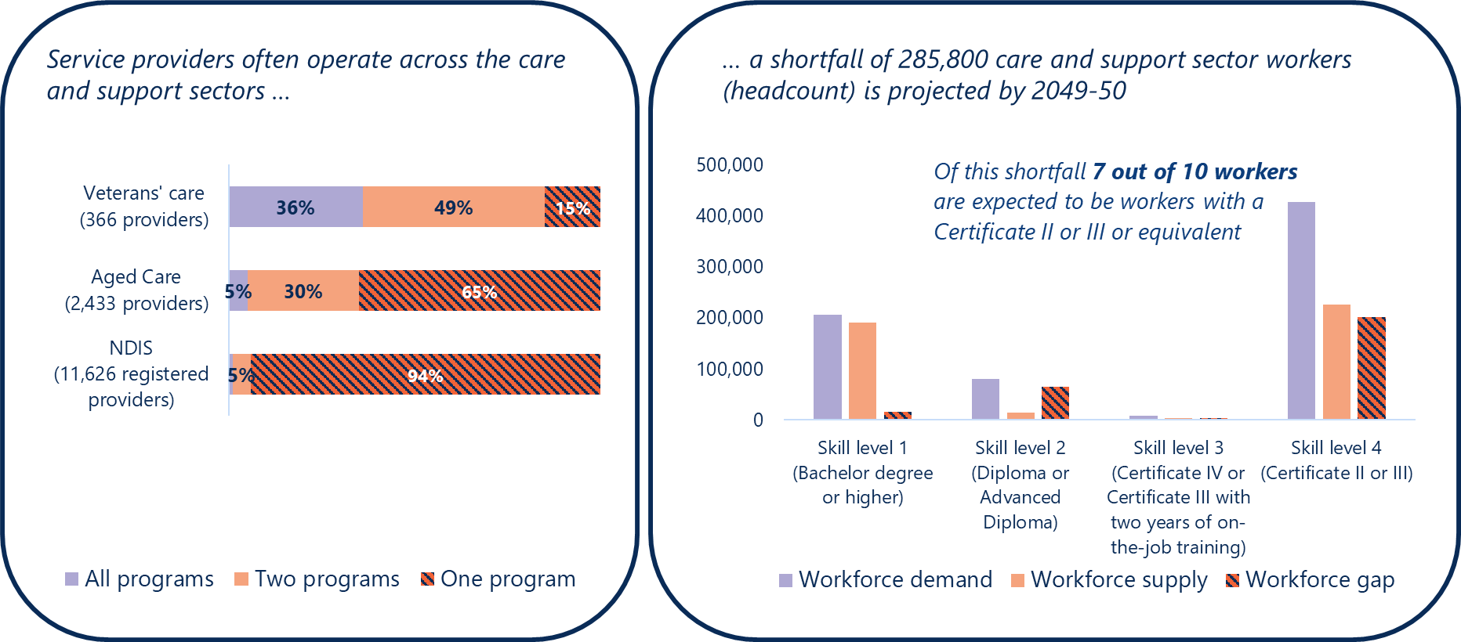
Text description of Figure 2
Numerous past reviews and strategies have considered the barriers to attracting and retaining an appropriate supply of care and support workers (Figure 3).
Yet there remains a largely fragmented approach to addressing workforce issues across the sector. Generally, reviews and strategies have often taken a siloed approach to developing program-specific solutions. While others have highlighted the need to better coordinate workforce development initiatives across the care and support sectors, but have not consulted widely with affected workers across the entire sector.
Past workforce strategies have also lacked accountability on how outcomes would be measured, making it difficult to tell if government actions have had any impact to date.
‘While monitoring and evaluation of the [NDIS Workforce] plan is expected throughout its life, the plan itself does not set out measurable outcomes that might be used to assess whether the plan is effective in supporting sustainable growth in the NDIS workforce. … The committee therefore remains concerned that, without adequate attention from the Commonwealth Government in this plan, many of the issues experienced by the NDIS workforce ... will continue to persist.’
- Numerous reviews and strategies have examined issues in the care and support workforce
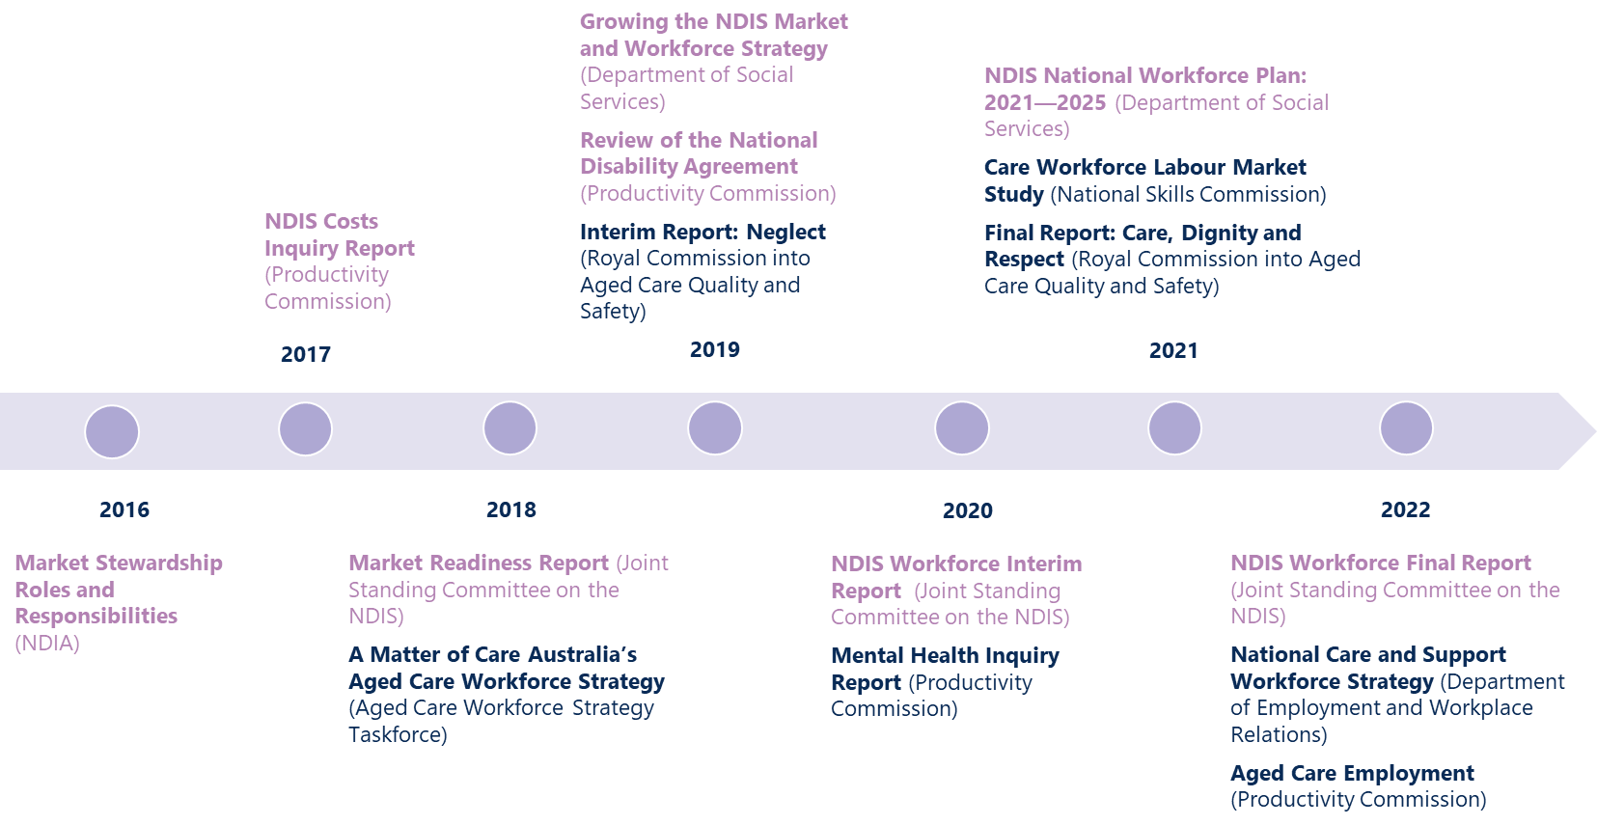
Text description of Figure 3

Finding 1
Meeting future workforce needs will require coordinated action across the care and support sector
There is a pressing need for a renewed focus on policies to grow the NDIS workforce. Within just the next three years, an expected additional 128,000 workers in the NDIS is needed to fully meet demand. This represents around a 40% growth in the workforce by June 2025.
Challenges in building the NDIS workforce are linked closely with the workforce challenges across the broader care and support sector. By 2049-50, demand for care and support workers is projected to double – at which point almost 1 in 20 jobs are expected to be in the care and support workforce.
While a number of workforce strategies have put forward initiatives to address these challenges, by and large, these strategies have seen a fragmented approach to addressing workforce issues across the sector. With little accountability on how outcomes from these strategies would be measured, it is hard to tell if they have had any impact.
Meeting future workforce needs will require coordinated action on workforce development across the care and support sector.

Workforce challenges are well known and widespread
The NDIS workforce has been experiencing acute pressures over the past few years which has been exacerbated by the onset of the COVID-19 pandemic, the closure of international borders and pronounced worker shortages. Around half of NDIS workers have reported that the pandemic made their work experience worse.
Before this, however, persistent workforce challenges in the NDIS have been widely known.
Workforce challenges are driven by multiple factors (Figure 4). Care and support jobs can be short term with high turnover, with poor conditions and career prospects. Around 2 out of 5 NDIS workers (43%) feel burned out at least half the time in their job.
Workers are leaving NDIS jobs at a faster rate compared to the wider economy. A relatively high share of workers work multiple jobs. This means employers face little incentive to invest in training workers.
Retention challenges were reported to be related to burnout and COVID-19 fatigue, as well as a lack of career pathways, the casualised nature of the work, low pay rates and leaving for ‘easier’ work in different sectors. A tight labour market creating increased competition for workers also plays into retention issues.

There are opportunities to modernise the training system …
Few workers in the sector work in traditional full-time ongoing employment – where a workers and employer directly share in the benefit of upskilling. Training systems, regulation and market settings, however, are not well set-up to support ongoing learning and career development for workers in non-traditional jobs.
Workers report having limited access to training and supervision (Figure 4). Issues with access to training and supervision may be exacerbated for the few workers who opt to move across to work independently via emerging platforms. Although, some platform workers value the flexibility, autonomy and potential for higher pay associated with independent contracting, helping keep them in the sector. The Productivity Commission found alternative structures for aged care employment, including platform workers, are an important part of meeting workforce demand.
Attracting and retaining capable staff in the NDIS will require a shift in the current training models and infrastructure. The future training system will need to adapt to provide effective models of on-the-job and progressive learning. Consideration also needs to be given to how NDIS price setting structures can support workforce training.
- Key workforce challenges
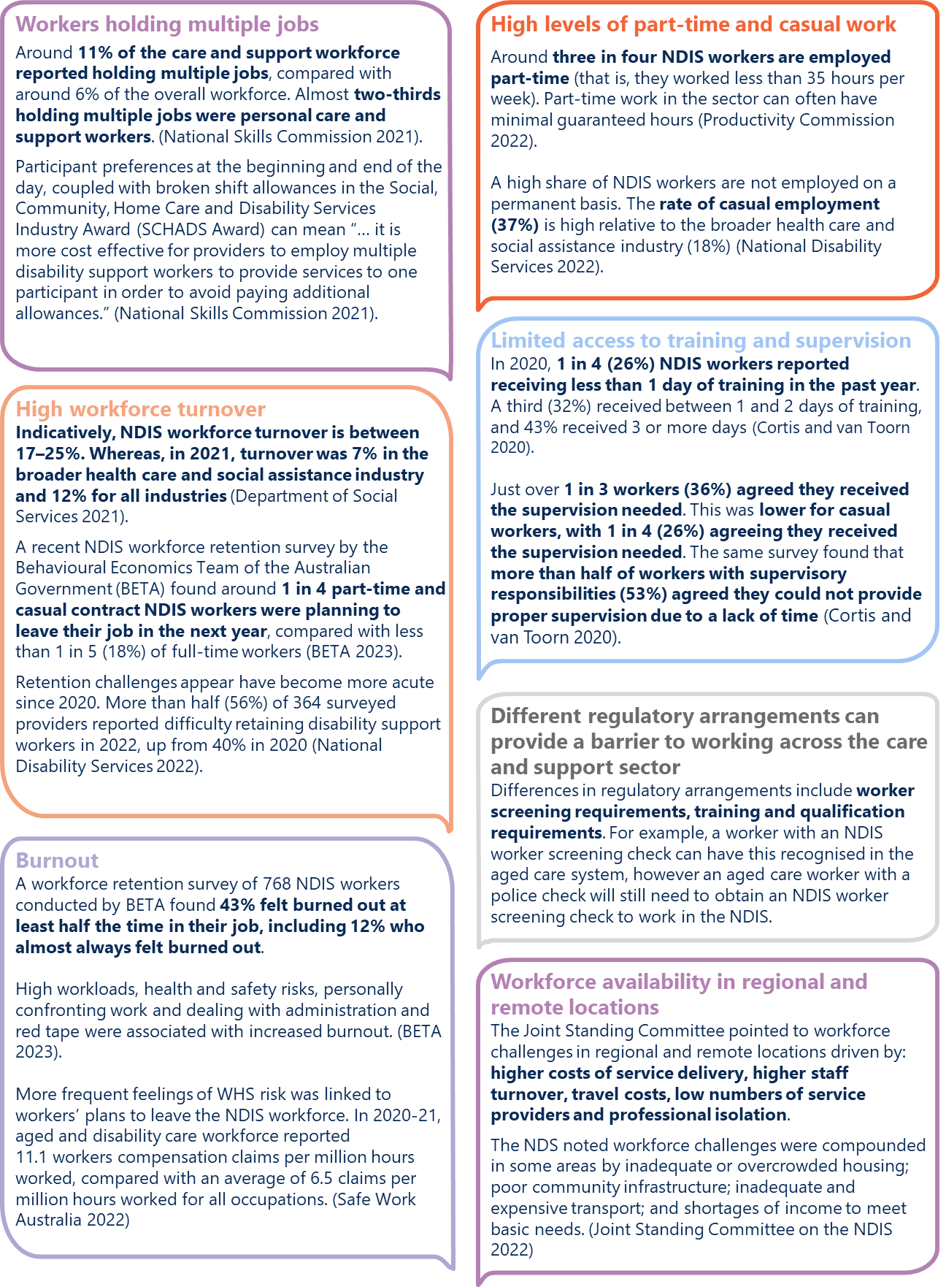
Text description of Figure 4

… and improve career pathways across the sector …
Removing barriers to workers transitioning over time between jobs in different parts of the care and support sector would open up opportunities for workers to build their career, both within, and across disability, aged care and veterans’ care.
These opportunities would help to keep workers in the sector. They would also support the dissemination of knowledge, practices and the use of productivity-enhancing technology (such as, more efficient rostering systems).

… but building the size of the workforce will be key
As the scheme matures, greater investment in capacity building, assistive technology and home modification supports could help improve outcomes for participants and reduce growing pressure on the workforce – by reducing reliance on ongoing core supports delivered directly by workers. For every dollar of funds allocated to participant capacity building and capital supports budget, currently less than $0.60 is spent.
That said, improving the effectiveness of the NDIS by itself will not solve the care and support workforce shortage. Workforce solutions will need to consider how to bring more workers into the care and support sector.
Drawing on current workers in the sector will help. Just over 1 in 10 care and support workers (13%) were underemployed in February 2021. That is, around 1 in 10 workers worked less than 35 hours per week, but were willing and able to work additional hours. In comparison, across the economy 9% of workers were underemployed. (Recent tight labour market conditions has seen underemployment rates across the economy fall to around 6% in late 2022).
Yet, this is not a panacea for future workforce needs. For personal care and support workers, just over half of underemployed workers in the sector were only willing and available to work up to 9 additional hours per week.
Attracting workers in sufficient numbers must involve improving the desirability of care and support work to draw in workers from sectors where technological change is reducing opportunities for labour and to bring in those outside the labour force.

Realising these opportunities will require targeted policy action
As major funders of care and support services, there is a clear argument for governments to take an active role in workforce development to ensure the effective, efficient and sustainable delivery of supports.
Policies that focus on attracting and retaining capable care and support sector staff will be critical to addressing the future workforce challenges facing the sector.
Moving the dial on meeting workforce challenges, however, will also require a look at how the NDIS is set-up and operating.
Regulation and market arrangements aim to ensure the delivery of quality NDIS supports that are responsive to participants. However, these arrangements also shape how providers deliver supports and models of employment. Worker screening requirements, for example, provide important protections for participants. However, if not well designed and clearly understood by potential workers, these arrangements may unintentionally discourage workers from entering the sector.

Targeted action is therefore needed across three of these policy areas
- Pathways and advancement into the care and support sector
It is important governments ensure barriers do not exist for workers and business to move and grow across the care and support sector.
Putting in place systems to support mobility could support career progression and encourage workers to remain within the broader sector.
- NDIS quality and safeguarding
The NDIS workforce faces different types of regulation depending on their profession, the type of supports they deliver, whether they are employed by a registered or unregistered provider. These differences are the result of the scheme’s risk-based approach that seeks to balance the need for appropriate protections while enabling participants to take reasonable risks so they can reach their goals. Quality and safeguarding arrangements will be considered in further detail through the Review.
- NDIS market settings
Market settings, including pricing and payment models, impact on the NDIS workforce. These will be considered in further detail through the Review.

Finding 2
New approaches are needed to attract and retain capable staff to the care and support sector to address workforce challenges
To attract workers in sufficient numbers to meet future demand, the desirability of care and support work needs to be improved. The sector needs to draw in workers from sectors where technological change is reducing opportunities for labour and to bring in those currently outside the labour force.
Removing barriers to workers moving between jobs in different parts of the sector would open up opportunities for workers to stay in the sector – to build their career across disability, aged care and veterans’ care. Moving away from ‘linear’ ways of providing training to be able to improve their skills progressively would also benefit workers who often work below full-time hours or in casual and non-ongoing arrangements.

Pathways and advancement in the care and support sector

Supporting workers to remain and advance in the care and support sector

New approaches to training
Ongoing skills development and training is crucial to ensuring that workers’ develop their knowledge and skills and can provide safe and quality supports to NDIS participants. Ongoing training is also essential for workers’ to further develop their skills and progress their careers.
The current training structures in the NDIS, however, are not working (Figure 4). Employers face little incentive to invest in training workers.
In its Interim Workforce Report, the Joint Standing Committee on the NDIS heard there is insufficient training provided in the sector – particularly to disability support workers.
‘The disability workforce is often required to self-fund training, as employers are unwilling or unable to deliver training under current price settings. In the absence of proper training, workers will have difficulty providing safe, quality services to participants, and may experience increased health and safety risks.’
Initiatives to modernise the training system are needed to support on-the-job progressive learning and upskilling – particularly for support workers.
Growing the number of traineeships for entry-level workers, micro-credentials and a digital skills passport are important modernising initiatives already agreed and underway. Greater use of traineeships, for example, could provide alternative pathways, for workers to complete the Certificate III in Individual Support, bypassing the need for 120 hours of mandatory unpaid work placement.

Traineeships combine training with a Registered Training Organisation (RTO), practical work experience and on-the-job training
Enable learners to ‘earn and learn’ and lead to attainment of an accredited qualification, such as a Certificate III in Individual Support or Certificate IV in Disability.
‘Aged or Disabled Carers’ and relevant Certificate III and IV qualifications are currently listed on the Australian Apprenticeships Priority List. This means that both employers and trainees are eligible for a range of Commonwealth incentives and subsidies through the Australian Apprenticeships Incentive System Program.
Employers of apprentices and trainees in priority occupations can claim a wage subsidy over the first three years of the apprenticeship or traineeship up to $15,000 in total. Eligible workers in priority occupations can also receive up to $5,000 in direct support to assist with the cost of living while they are completing their apprenticeship (part time workers receive up to 50%, or $2,500). These incentives are available to eligible apprentices and employers who commence training prior to 1 July 2024.

Micro-credentials support career pathways in the care and support sector
Micro-credentials are short courses or competencies that can be used to rapidly upskill and reskill the workforce.
Micro-credentials can also be combined with other competencies to build knowledge and skills into full qualifications.

Digital skills passport
A digital skills passport, once developed, would provide a practical tool to help workers record and track their training – including micro-credentials and unaccredited training – supporting workers to build towards a full qualification and removing barriers to working across the care and support sector.
The NDIS National Workforce Plan: 2021–2025 identified all three as priority actions. The Review considers that these initiatives should apply across the care and support sector and should be progressed as a priority.
Other existing initiatives could also be built on to support training.
Growing student placements, particularly for allied health students, in disability and aged care settings could help build connections and career pathways to the sector, as well as improving the capability of allied health professionals. Improved support for supervision in the NDIS model could assist with placing students.
The existing NDIS Workforce Capability Framework describes the attitudes, skills and knowledge expected of all workers in the NDIS. The Framework has been leveraged in the development of training materials for NDIS workers including the Certificate III in Individual Support and Certificate IV in Disability Support, which were revised at the end of 2022. Over the coming year, it will be important to review the impact of these changes to ensure they are improving workers’ understanding and ability to deliver supports within a human rights framework. If successful, the Framework should be used in the development of training materials across the care and support economy. Even so, more needs to be done.
A key barrier to undertaking ongoing training is the time required to undertake training, particularly if unpaid. A portable training scheme, which could fund paid time off as well as course costs, could assist in addressing this barrier.
This is not a new proposal.
‘… a number of countries acknowledged the need to put in place systems of lifelong learning that could deal with increasingly non-linear career paths and support individuals as they move between jobs, careers, training and other absences from the labour market throughout their lives. One important element of this is portability of training rights and the portability of skills themselves.’
France introduced the Compte Personnell de Formation (CPF), a personal training account scheme in 2015. The CPF is a scheme for financing training that is linked to individuals and fully transferable throughout a person’s working life. In this case, the CPF is funded through an employer levy and if a worker is self-employed they pay a flat-rate contribution.
In 2018, the Joint Standing Committee on the NDIS recommended that the NDIS Quality and Safeguards Commission (NDIS Commission) review options on how to ensure disability workers under the NDIS can access funded training, including considering the introduction of a portable training entitlement system.
The Centre for Future Work’s 2018 report on A Portable Training Entitlement System for the Disability Support Services Sector, proposed a system where disability support workers would be credited 1-hour of paid training for every 50 hours of NDIS-funded work. Under the Centre’s proposed scheme, credits would be vested with individual workers, allowing them to accumulate credits even if they work for multiple employers or as sole traders.
The Australian Services Union (ASU), which commissioned the Centre for Future Work’s report, stated in a submission to the NDIS Review that ‘… funding support for the worker to take the time to complete the study [was] a critical component to support course completion in a low-wage, insecurely employed, fragmented workforce’.
We consider there are potential benefits to a portable training scheme for the care and support sectors.
That said, as with any scheme, it will be important to ensure design and implementation of the scheme achieves the intended policy outcome and avoids unintended effects. Key design features include:
- System infrastructure – for the scheme to enable applicability across the broader care and support sector. This would need to include a mechanism to link training credits to hours of work performed across multiple providers
- Eligibility criteria – including the threshold to establishing an account for workers, and whether accredited or non-accredited courses (or both) would be eligible
- Funding approach – that is, if the scheme should be funded via industry, government, through participant/client funding packages or a combination.
We consider there are benefits in trialling a portable training scheme across the care and support sector. The design of a proposed scheme and the trial should be developed in close consultation with care and support workers, employers and participants/clients.
It is worth highlighting that as major funders of care and support services, government would implicitly fund such schemes. As such, the trial should be designed to measure the contribution portable training makes to supporting the size and capability of the care and support workforce, and consider if training would be better supported using alternative arrangements.

Supporting workers to remain in the sector
The flexible nature of many care and support sector jobs is part of a broader labour market shift to various forms of non-standard employment. How to best support workers engaged in these types of work is a question that has been examined in both Australia and internationally.

Box 1
Industry-specific portable long service leave schemes operate across Australia, with some already applying to care and support workers
The Queensland, Victorian and the ACT governments have portable long service leave schemes covering the community services sector within their jurisdiction – capturing disability workers and some other care and support sector workers. Principles underpinning these schemes are broadly similar (see table below).
Eligibility for leave is based on time served in an industry, rather than with a single employer. Schemes are funded through an employer levy on wages and paid into a central fund, when a worker becomes entitled to long service leave their entitlement is paid out of the central fund and not their current employer.
 | Queensland | Victoria | ACT
Commenced | 1 January 2021 | 1 July 2019 | 1 July 2010
Leave Entitlement | 6.1 weeks | 6.1 weeks | 4.33 weeks
Worker Service Required | 7-years | 7-years | 5-years
Employer Levy | 1.35% of ordinary wages | 1.65% of ordinary wages | 1.6% of ordinary wages
Blanket Exclusions | Commonwealth, State and Local Government workers | Commonwealth, State and Local Government workers | Commonwealth and Territory workers
Which care and support sectors are covered?
 | Queensland | Victoria | ACT
Disability | Yes | Yes  (1 January 2020) | Yes
Aged care  (in-home & community) | Yes | Yes | Yes  (1 July 2016)
Aged care (residential) | No | No | Yes  (1 July 2016)
Note: while these three schemes can apply to independent contractors/sole traders, payment of the levy is optional.
When establishing its new portable long service leave scheme for the community services sector, the Queensland Government’s Office of Industrial Relations suggested the scheme would provide ‘considerable benefits for the sector in the attraction and retention of skilled and experienced employees which will be realised in reduced recruitment and training costs over time and a stronger more resilient workforce to support Queensland communities’.
However, to-date, we are not aware if any robust evidence showing these schemes support worker attraction and retention. An evaluation of the ACT scheme may help shed light.
The COVID-19 pandemic accelerated public debate on the merits of expanding paid leave entitlements to more types of workers — including casuals and contractors. Last year, the Senate Select Committee on Job Security in its Job Insecurity Report (2022) recommended the Australian Government undertake a review of the current portable leave schemes and examine where such schemes could be extended to workers in other industries, in consultation with employer and employee groups, and state and territory governments.
Industry-specific portable long service leave schemes are operating in some states and territories. This includes schemes that already cover disability workers in Queensland, Victoria, and the ACT (Box 1). While the hope is portable long service leave could support retention of workers in the sector, the Review could not find any robust evidence around retention. What’s more, by its nature, long service leave has a long qualifying period and, therefore, does not address the high volume of turnover during the first year of employment in care and support jobs.
Evidence from Australia and England suggests that turnover for care and support workers is highest within the first year of employment. In England, care workers with less than one year experience had a turnover rate of around 44% compared with 24% for workers with five years’ experience. In Australia, the National Skills Commission noted turnover in the occupation aged and disabled carers in the first year of employment was a significant challenge for providers.
Portable arrangements for sick and carer’s leave do not exist on the same scale as portable long service leave arrangements. However, these schemes may help with early retention issues – as workers are supported and rewarded early for continuing to work in the sector, without requiring them to stay in the same job.
Incolink, an industry-led worker entitlement scheme covering construction workers in Victoria and Tasmania, provides portable sick and carer’s leave to employees of participating businesses. Under the scheme, when a construction worker has exhausted their sick and carer’s leave entitlement from their current employer, they become eligible to use leave from a previous employer (capped at 100 days). The scheme is only available to workers who have an entitlement to sick and carer’s leave, that is, it does not cover casual or contract workers.
In 2015, Nous Group undertook an evaluation of Incolink’s various benefit programs (including portable sick and carer’s leave) which estimated the annual net benefit to be
$4 million per annum attributed to the portable sick and carer’s leave scheme.
The Victorian Government recently commenced a pilot – Victorian Sick Pay Guarantee – to provide eligible casual and contract workers up to 38 hours per year of sick and carer’s leave paid at the national minimum wage. The pilot commenced in May 2022 and will run for two years. Aged and disability care workers are one of nine categories of occupations included in the Victorian pilot. As at 5 January 2023, 55,000 workers had registered for the program and 80,000 payment claims had been processed. The Victorian Sick Pay Guarantee pilot is funded directly by the Victorian Government.
We consider that a national sector-wide portable sick and carer’s leave scheme could support the retention of workers across the care and support sector. This could help workers stay in the sector and support early career progression opportunities. Participants, governments and providers may benefit from increased dissemination of knowledge, practices and the use of productivity-enhancing technology.
However, scaling-up to implement a portable sick and carer’s leave scheme is not without drawbacks. If not well designed, a portable sick and carer’s leave scheme could unintentionally push more workers to casual work (where employees are entitled to a 25% casual loading in lieu of access to paid leave entitlements). Getting efficient administrative arrangements will also be key to ensure any scheme delivers benefits to the sector overall. In the case of an employer levy funded scheme, providers would also need to make provisions for sick and carer’s leave liabilities.
Further consideration is needed on the costs and benefits of any national sector wide portable sick and carer’s leave scheme. We consider a scheme should be first designed and trialled, and evaluated before any further roll-out. Central to any design would be consideration on eligibility, how it would interact with existing legislative and regulatory requirements, and who would be responsible for funding the entitlements.

Recommendation 1
Design and trial workforce attraction and retention initiatives
The Australian Government, supported by the Care and Support Economy Taskforce, should work with states and territories to design and trial initiatives for the care and support sector to better understand what works.
These initiatives should include designing and trialling in close consultation with care and support workers, employers and participants/clients:
- portable training scheme in close consultation with care and support workers, employers and participants/clients
- portable sick and carer’s leave scheme.
Both these trials should give consideration to the system infrastructure, eligibility criteria and funding approach that would ensure benefits exceed costs and the scheme would be widely adopted.
Complementary initiatives – to develop micro credentials, a digital skills passport and support to grow the use of traineeships for entry-level workers – that have already been agreed for the NDIS should be progressed as a priority across the care and support sector.

Strengthening pathways into the sector
To meet future workforce needs, the care and support sector needs to do much more to draw in workers (Finding 2).

Attitudes, values and personal attributes are essential for those wanting to work in the care and support sector
A 2017 survey of care and support employers found that employee attributes are particularly important for disability providers, with employers ranking personal qualities as more important than both qualifications and experience. These include cultural sensitivity and awareness, dependability, attention to detail, willingness to learn new things and communication. Participants place high value on workers’ having a knowledge of disability and the human-rights framework underpinning the NDIS.
To this end, the NDIS Commission’s existing Workforce Capability Framework provides a self-assessment tool for prospective workers to check if they would be suitable for, and interested to, work in this sector.
The Department of Employment and Workplace Relations has also developed an online self-reflection tool to assist job seekers to reflect on their values and working style and help them consider whether they will be a good fit for work in the broader care and support sector. The tool also makes suggestions on which areas of the sector might be a better match for them. To help improve awareness of the job opportunities in the sector, the department has also developed a short video that provides an introduction to the range of roles in the sector.
If effective, these tools should assist with better matching workers, lowering the cost to businesses and participants associated with high turnover in the sector (Figure 4).
State and territory governments also implement a number of employment programs which seek to provide tailored solutions when matching job seekers to local jobs (Box 2). A key characteristic of these programs is tailored solutions that provide new workers with holistic supports as they transition into the sector.
However, without program evaluations (including impact evaluations), it is not possible to understand the extent to which these approaches were able to up-lift workers into the sector. This highlights the need to embed evaluation early in program design.

Box 2
More evidence is needed on understanding what works to attract workers into the sector

‘More Jobs More Care’ initiative in NSW provided new workers with holistic supports
The NSW Government Initiative provided funding for 2,500 individuals to undertake a free 4-week pre-employment program which provided a pathway into a job as a disability support worker. The program targeted school-leavers as well as people who lost work due to the pandemic.
Key elements included:
- delivery of at least four accredited learning modules, including a First Aid Certificate. These modules count towards a Certificate III in Individual Support if learners opted to continue training.
- 15-hours of workplace-based training.
- mentoring and support for learners during training as well as ongoing professional development support upon commencing work.
- payment for relevant worker screening checks: National Police Check, Working With Children Check and NDIS Worker Screening Check.

‘Jobs that Matter’ initiative in Victoria
The Victorian Government ran a public campaign to boost workforce attraction in the community service sector. The Jobs that Matter campaign provides information about employment in this sector, the contribution it makes to the lives of Victorians, and the opportunities available to support the community services workforce in 2021-22 and beyond.
The program included three phases:
- awareness, which showcased the sector and opportunities available
- an integrated recruitment campaign to build the community services workforce
- targeting youth by putting the community services sector on the radar as students and young people considering pathways to employment.
No evidence is currently available on the extent to which either program was able to attract workers to the sector. This highlights the need to embed evaluation early in program design.

Could employment service providers be further incentivised to assist job seekers into the sector?
In addition to smaller tailored programs, mainstream employment service programs – Disability Employment Services (DES), Workforce Australia and, in remote locations, the Community Development Program (CDP) – have an important role in guiding unemployed job seekers to take up opportunities in the care and support sector. These job seekers have often been out of work for some time or face other employment challenges.
Employment service providers are paid outcome payments when they place a job seeker into a job for a period (typically at 4-weeks, 12-weeks and 26-weeks). The value of outcome payments increases the longer a job seeker remains employed.
The nature of many care and support sector jobs – sometimes characterised by low, variable hours and casual jobs with high-turnover rates – could put outcome payments for employment services providers at risk. To some extent, this may provide a disincentive for employment services providers to place job seekers into care and support jobs.
The Review notes these incentives could be reviewed for the care and support sector, taking into account that any job seeker referred to these roles should have the appropriate skills, values and attitudes.

Supporting the peer workforce
Workers with lived experience – so called peer workers – are a critical, but underutilised, part of the care and support sector.
More must be done to increase the representation of people with disability in the NDIS workforce.
In addition to improving employment outcomes for people with disability, the workforce needs to grow to meet demand and improve quality by harnessing the untapped potential of people with lived experience.
The Joint Standing Committee on the NDIS heard workers with disability faced discrimination and challenges when trying to enter the workforce – this includes employers being unable to see past the disability, building accessibility issues and the misconception that employers will need to provide significant additional support.
The Joint Standing Committee on the NDIS recently outlined steps to help develop the peer workforce in the NDIS.
‘The committee recommends the Australian Government implement a targeted strategy to improve employment opportunities for people with disability within the NDIS workforce specifically, that is co-designed by people with disability and peak bodies.’
In response the Australian Government indicated that the NDIS Participant Employment Strategy 2019-2023 has a goal to enable 30% of participants of working age to be in paid work by 2024. We support this ambition.
There are also some barriers to work that could be removed now. We note the 2020 Productivity Commission Mental Health inquiry (Action 19.5) recommended removing barriers to work for Disability Support Pension (DSP) recipients.
Under the current criteria, DSP recipients may lose eligibility for DSP (and any additional concessions they were eligible for) after a sustained period of employment of 30 or more hours a week. This can put up a barrier to recipients working additional hours of work. The Productivity Commission recommended the weekly hour limit be increased to 38 full time hours per week (to match the ordinary hours of work in the National Employment Standards).
The Australian Government is also undertaking a pilot program that would trial an employment concierge within the NDIA for people with disability in the NDIS.
From early 2023, the concierge would provide expert advice and a supporting hand to people who want to work. NDIS participants who have an employment goal will be supported to engage with a Disability Employment Services (DES) provider and to coordinate the support they receive through both NDIS and DES.
Where these participants choose to work in the NDIS, it will further support the valuable work a peer workforce would provide to participants. The concierge program should be evaluated with people with disability to assess its impact.

Finding 3
More focus on peer workers will improve the quality of support provided across the care and support sector
Steps to promote positive examples of peer workers in the workforce, as well as additional support and mentoring opportunities for peer workers could be explored.
There may be benefits from mapping peer workers to meaningful employment opportunities – including in the care and support sector – and identifying goals for peer workers and funding appropriate training supports. This could be considered further as part of the current employment concierge trial for NDIS participants who have an employment goal.

Targeted migration can help fill acute workforce gaps
Migration can play a role in supplementing the domestic care and support workforce where gaps are not able to be filled by domestic workers in the short-term. In 2021,
2 in 5 workers in the care and support workforce were born overseas (compared to around 1 in 3 in the overall workforce).
Some roles in the care and support sector (including allied health professionals and other highly-skilled workers) qualify for skilled migration. Migration pathways are more limited for aged care personal care workers and disability support workers.
As noted above, the expected shortfall of workers across the sector are concentrated in the occupation groups Aged and Disabled Carers and Nursing Support and Personal Care Workers (Figure 2). Some recent changes have broadened options for lower-skilled workers to help with immediate gaps – including training for 500 Pacific Australia Labour Mobility (PALM) scheme participants to complete their Certificate III in Individual Support (Ageing) in 2023 while they work for up to four years in Australia, and temporarily relaxing work hours restrictions for student visa holders to June 2023.
Additional effort and initiatives could be used to address short-term workforce gaps across the NDIS and broader care and support sector. However, these efforts should be flexible and do not replace the need for effective workforce planning (see discussion below).
Industry labour agreements can potentially offer a flexible pathway that can be responsive to labour market conditions and limited to workers with suitable skills, values and attitudes. This could be revised and removed as needed after a five year period and include minimum language proficiencies and labour market testing requirements.
Given the competition for migrant labour both within Australia and from overseas, it will be important to find ways to attract migrant workers, with the level of skills, values and attitudes that meet local demands, to take up these opportunities. One way this could be done is to offer pathways to permanent residency as part of the industry labour agreement. Migrant workers should enjoy the same labour standards and entitlements as the domestic workforce.
The Australian Government is currently undertaking a review of Australia’s migration system, to ensure it serves Australia’s national interests and complements the skills and capabilities of Australian workers. Any migration pathways for care and support workers should align with the outcomes of this review.

Recommendation 2
Develop targeted and flexible migration pathways for care and support workers
The Australian Government should consider developing an industry labour agreement for the broader care and support sector targeted at workers who would not otherwise qualify for skilled migration. This industry labour agreement should be developed in consultation with industry and relevant employer associations and unions.
The agreement should be reviewed within five years to ensure the agreement is flexible and responsive to changing labour market conditions. This agreement should also consider appropriate requirements to attract migrants with suitable skills, values and attitudes. This could include minimum skills and language requirements. A streamlined pathway to permanent residency should also be considered.

Better sector-wide workforce planning
Continuing down the path of focusing on a one-off sector workforce strategy is unlikely to result in workforce planning that is responsive to changing labour market conditions. And is unlikely to deliver the joined-up approaches needed to enjoy the benefits of sector wide initiatives.
Ongoing sector-level governance and accountability is needed to ensure a joined-up approach to workforce planning that is lasting. This is critical if governments are going to see the dividends of the proposed new approaches.
The recently established Care and Support Economy Taskforce would be well-placed to take on this role and to push forward on sector-wide workforce initiatives (Figure 5).
This role would include responsibility for overseeing the different elements of workforce planning, including developing a data strategy – currently lacking for the care and support workforce (Figure 5). The Taskforce should work with Jobs and Skills Australia (JSA) in its role in analysing and reporting on emerging, and future workforce, skills, and training needs across the economy.
The Taskforce would also coordinate targeted policy action and oversee ongoing monitoring, evaluation and improvements. This should include overseeing the design, trial and evaluation of the workforce attraction and retention initiatives outlined in Recommendation 1.
The work of the Taskforce should complement, but not duplicate or replace the work of the newly established Jobs and Skills Councils (JSCs) in the VET sector. The dedicated JSC for the health and human services, early education, and sport, fitness and recreation sectors aims to provide industry with a stronger, more strategic voice in ensuring Australia’s VET sector delivers stronger outcomes for learners and employers. These JSC’s will identify skills and workforce needs for their sectors, map career pathways across education sectors, develop VET training products, support collaboration between industry and training providers to improve training and assessment practice and act as a source of intelligence on issues affecting their industries.
- A sector-wide approach to workforce planning is needed
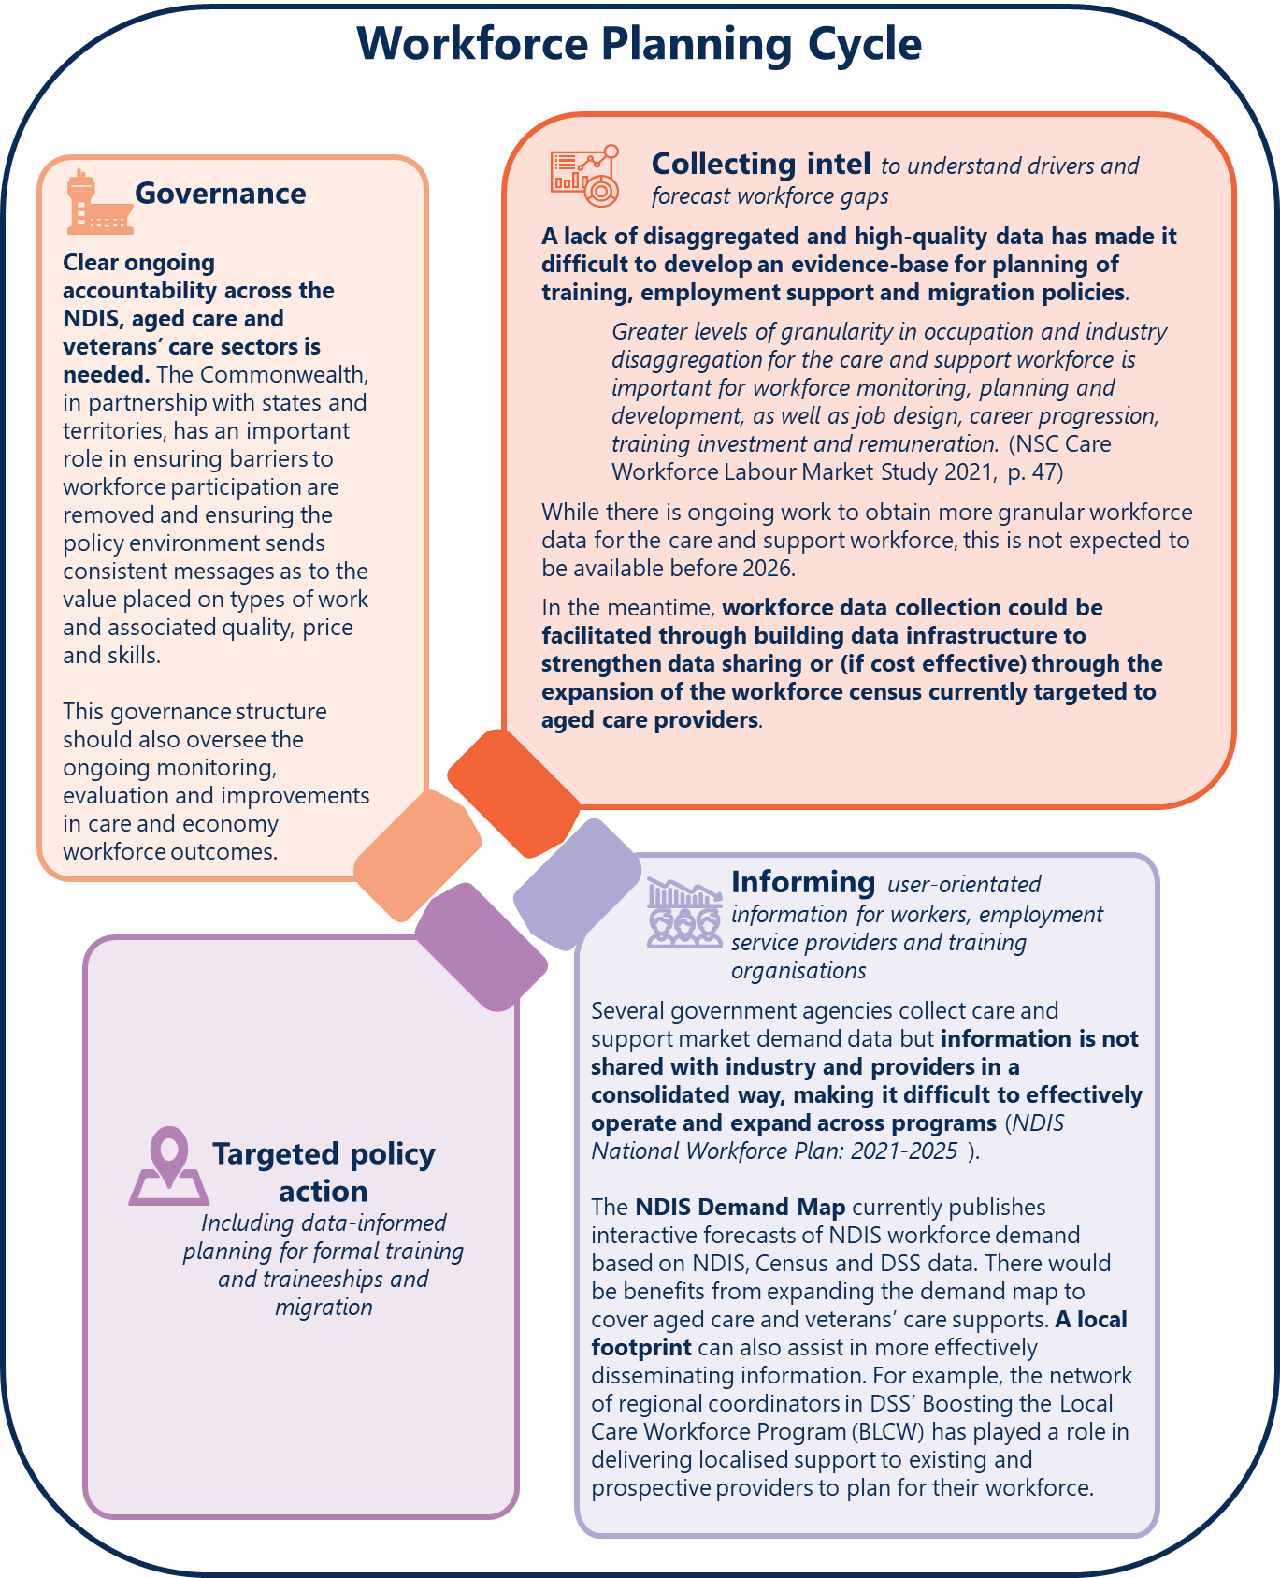
Text description of Figure 5

Recommendation 3
An integrated approach to workforce development for the care and support sector
The Australian Government, through the Care and Support Economy Taskforce, should establish an ongoing governance function to coordinate workforce planning and ensure the development of a sustainable care and support workforce.
This function should collaborate across the Commonwealth, states and territories and have responsibility for:
- developing and overseeing a data strategy which incorporates data collection and demand and supply projections. This should be shared with industry to support providers, training organisations and workers to be responsive to changing market conditions
- identifying workforce gaps and work across governments to develop targeted policy responses
- monitoring and evaluating actions and disseminating ongoing learnings.

NDIS quality and safeguarding – workforce requirements
The NDIS seeks to take a risk-based framework to regulation of providers and workers. It aims to balance the safe delivery of supports while enabling participants to take reasonable risks so they can reach their goals.
As part of this framework, workers are required to undertake an NDIS worker screening check when working in a risk-assessed role with a registered NDIS provider. The screening check is optional when working with unregistered providers. Other system-wide worker regulations can also apply, for example, registration standards for allied health professionals regulated by the Australian Health Practitioner Regulation Agency (AHPRA).
The scale and scope of the NDIS regulatory arrangements underpin the safe and effective delivery of supports. These arrangements, and how they apply to workers in the scheme, will continue to be examined throughout the Review. The Review will provide further opportunities for stakeholders to engage on a range of issues relating to regulation and quality and safeguarding arrangements in the NDIS.
This includes considering the merits of extending worker screening to those working for unregistered providers, including those engaged via some platforms. Initial consultation with providers and worker representative organisations undertaken as part of this Review indicates a diverse range of views on the subject.
Ahead of this work, there are some issues that can be progressed immediately to improve the current operation of worker screening checks.

Processing the NDIS worker screening check could be faster and simpler
The NDIS worker screening check is a nationally consistent check which is portable across jurisdictions. States and territories operate Worker Screening Units (WSU), which assess and process NDIS worker screening applications. The results are then uploaded to the NDIS Commission’s National Worker Screening Database.
There are multiple steps involved in processing an NDIS worker screening check as well as operationalisation differences across states and territories (Figure 6, Table 1).
Taken together, these arrangements can create delays for employers in sourcing the workers they need, including creating barriers for workers in other sectors from joining the NDIS workforce. There are opportunities to improve the speed of worker screening checks including by removing the need for an employer verification before a check is processed. Workers should still be linked to a provider, but this could be done later in the process and not delay finalisation of the screening process itself. Consideration should also be given to allowing workers to commence work on application in all jurisdictions with appropriate and aligned risk mitigation measures. Manual processing in some states and territories should also be minimised and sped up.
Additionally, there should be greater transparency on the total time taken to progress an NDIS worker screening check (WSC) – from the point a worker applies to when they receive either a clearance or exclusion. Available reporting by the NDIS Commission on processing times currently covers only two out of the three steps involved in processing an NDIS worker screening check (Figure 6, Table 1). We have requested validated average worker screening processing times through the NDIS Worker Screening Steering Committee. We will publish these times once available.
- There are multiple steps involved in processing NDIS Worker Screening Check applications and opearationalisation differences between states and territories
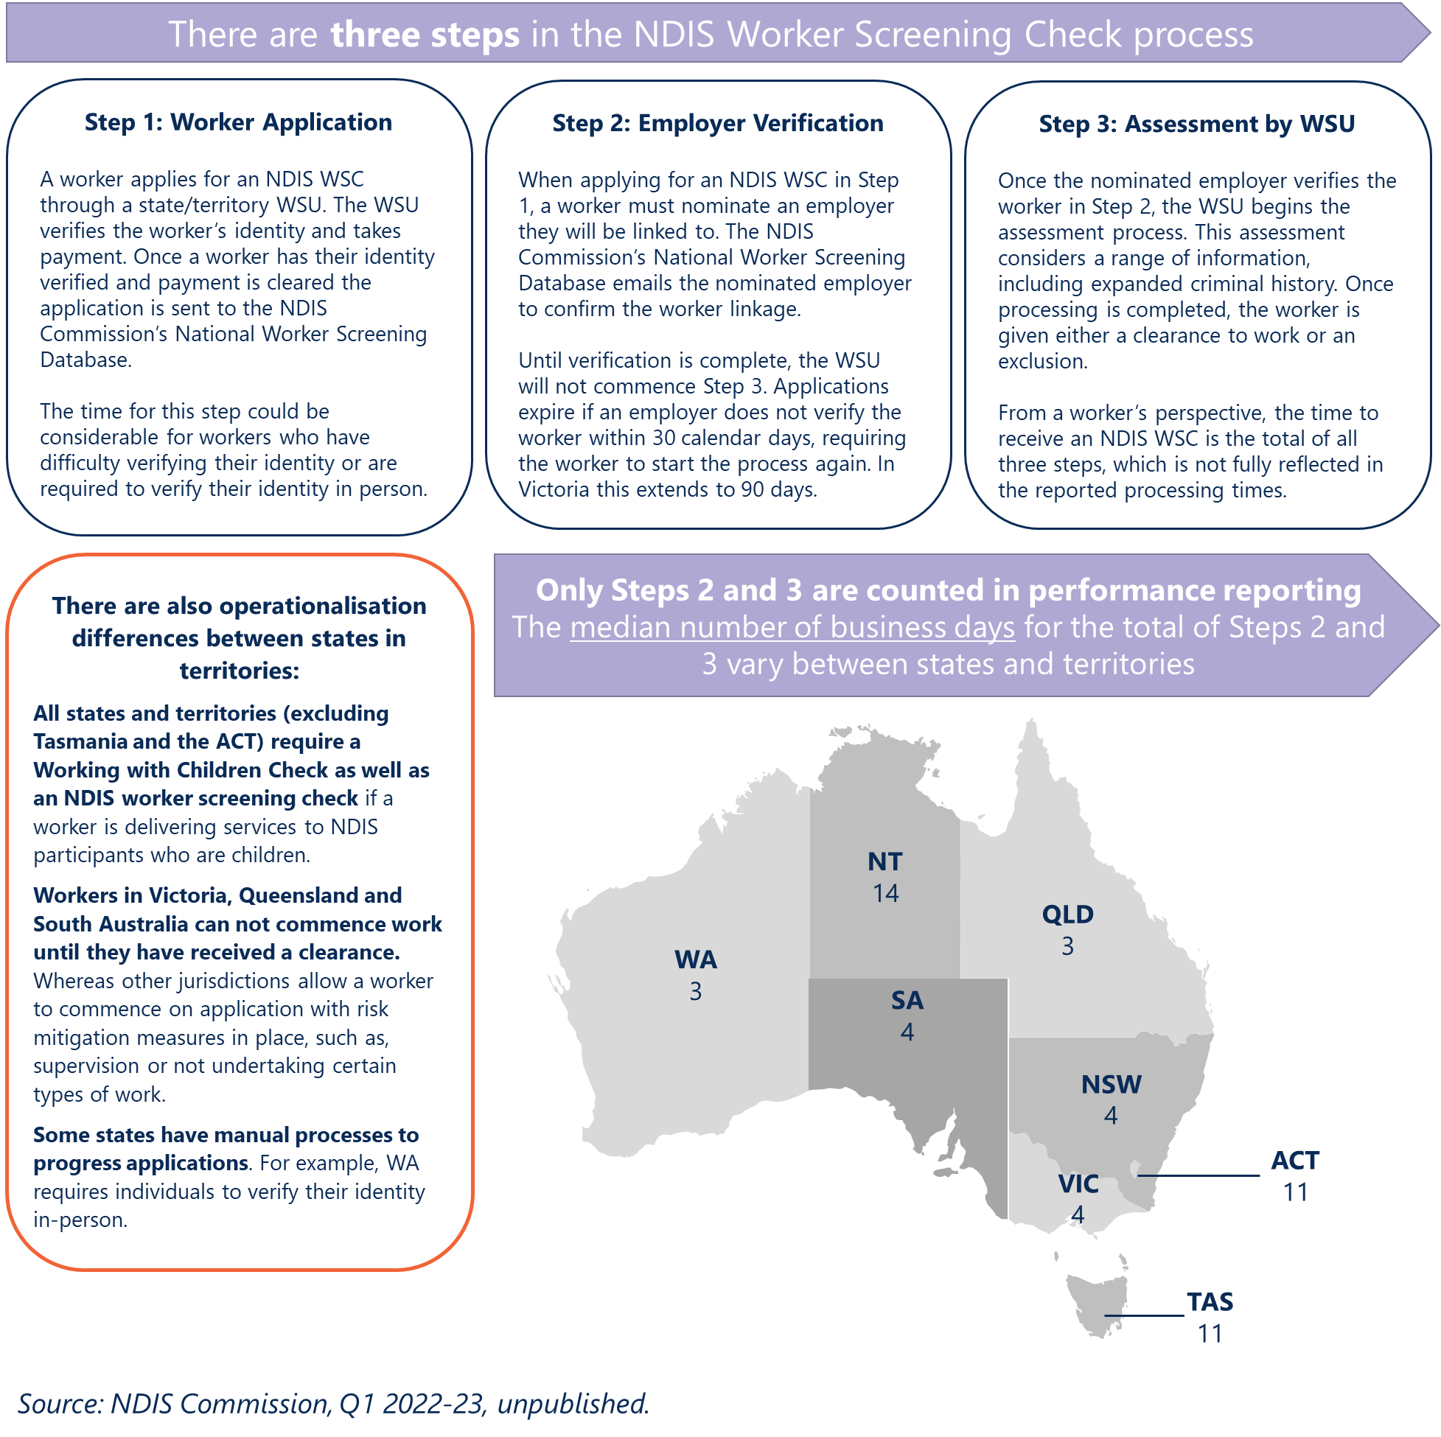
Text description of Figure 6
Table 1. The median number of business days for each step also varies between states and territories
 | ACT | NSW | NT | QLD | SA | TAS | VIC | WA
Verification (Step 2) median | 8 | 3 | 11 | 2 | 3 | 6 | 3 | 2
Assessment (Step 3) median | 3 | 1 | 3 | 1 | 1 | 5 | 1 | 1
Total (Step 2 & 3) | 11 | 4 | 14 | 3 | 3 | 11 | 4 | 3

These changes would make it easier and quicker for workers entering the sector.
In 2022, the Australian Government announced the development of a National Aged Care Worker Registration Scheme, which will include worker screening requirements.
It will be important that as this is designed, it aligns with the NDIS worker screening check and that the checks are mutually recognised across sectors. Indeed, for a provider applying to become an approved aged care provider, currently the Aged Care Quality and Safety Commission can already recognise NDIS worker screening checks in lieu of police checks for staff.

Recommendation 4
Streamlining worker screening processes
The Australian Government, through the Regulatory Reform Division in the Department of Finance, should work with state and territory governments to improve and streamline worker screening processes for care and support workers.
The current processes for the NDIS worker screening check should be improved and streamlined without reducing the level of safeguards offered under the NDIS by:
- reducing worker screening processing times by removing the requirement that an application for employees needs to be verified by an employer (providers can link to workers after the clearance is complete)
- considering expanding work on application provisions to all jurisdictions with appropriate and aligned risk mitigation measures
- exploring if NDIS worker screening checks could be recongised as fulfilling the requirement for Working with Children Checks (WWCC) and Police Checks, across all jurisdictions
- improving the efficiency and quality of checks by minimising reliance on manual processes. This should include looking at opportunities to improve data sharing, systems design, IT requirements and draw on existing established identification systems (such as, but not limited to, MyGov)
- providing greater ongoing transparency on end-to-end clearance times, with improved data quality to ensure comparability between jurisdictions.
This should also include ensuring the aged care worker screening requirements being developed as part of the National Aged Care Worker Registration Scheme align with the NDIS worker screening check, and that checks are mutually recognised across programs.

NDIS market settings
The transformational shift from block funding to an individualised market-driven approach has resulted in supports that are more tailored and responsive to participants. Providers and workers have evolved to respond to participants’ needs.
Within the design of the NDIS market, certain factors and settings are likely to have shaped provider operating models and practices as to how the NDIS workforce grew.
Uncertainty in participant demand, at least throughout the transition phase, may have contributed to a greater use of casual work. Casualisation increased from 36% of all NDIS workers in 2016 to a high of 40% in 2019. More recently, the rate of casual workers to permanent workers declined to 33% in June 2021, increasing again to 37% in June 2022, indicating potential instability.
Pricing and payment settings – including price caps – will affect the attraction and retention of workers and wage outcomes. These settings are also likely to affect training outcomes and supervision levels. The inclusions for training and supervision for disability support workers in hourly price caps, when set at a sufficient level, may help ensure workers receive appropriate training and supervision to be able to deliver safe and quality supports. In practice, however, training and supervision outcomes will depend on a range of other factors. Feedback from providers in past reviews suggests the NDIS pricing arrangements do not sufficiently allow for training and appropriate supervision.
Minimum training requirements, and the level of enforcement will drive training outcomes, as will the level of information provided to participants on the ‘quality’ of supports provided and the extent to which they value this quality. Market conditions, including the level of competition in the sector and broader labour market tightness, will also shape training and other outcomes.
This highlights the need to consider NDIS market settings, monitoring and thin market arrangements in a holistic way. These issues will be explored throughout the Review as part of a broader analysis of market stewardship arrangements.

Next steps
We will continue to consider a number of workforce issues that intersect with other elements of the NDIS. This includes examining the critical relationship between workforce issues and NDIS regulation and market settings, including pricing and payment settings. To improve outcomes for participants and help reduce growing pressure on the workforce, we will also consider ways to improve market arrangements and support greater investment in capacity building, assistive technology and home modification supports.
In recognition of the critical work of the peer workforce, we will also look at how these workers can be better supported.
Through exploring alternative commissioning approaches with remote and First Nations communities, we will also seek to build the local workforce in remote communities as well as a culturally competent workforce to deliver supports to First Nations participants.

Appendix 1: Alternative text

Figure 1 text description
A group of boxes with information on different parts of the NDIS workforce, the broader care and support workforce, platform workers and informal carers.
Box 1 - Data on Disability Support Workers. There were 280,000 workers in 2021-22 and 385,000 workers are required to fully meet demand by June 2025. 8 in 10 work part-time, 7 in 10 are female and 6 in 10 are aged 44 or under.
Box 2 - Data on Allied Health Workers. There were 36,000 workers in 2021-22 and 51,000 workers are required to fully meet demand by June 2025. This group includes both allied health professionals and allied health assistants. In the year to 20 September 2022, allied health services accounted for around 13% of NDIS payments.
Box 3 - Data on Other Workers. There were 9,000 workers in 2021-22 and 17,000 workers are required to full meet demand by June 2025. These workers provide a diverse range of supports and include, for example, support coordinators, interpreters, gardeners and cleaners.
Box 4 - Information about the broader care and support workforce. 4 in 5 hold a Certificate III qualification or higher, compared with 66% of the broader labour market. Enrolments in relevant VET qualifications increased by around 6.5% between 2015 and 2019, however, completions declined by 4.6%. Almost 4 in 10 were born overseas, compared to 32% of the overall workforce.
Box 5 - Data on emerging platform workers. The number of workers supporting NDIS participants through online platforms is small, but growing. In 2021-22, around 16,000 NDIS agency and plan-managed participants had used a platform provider.
Box 6 - Labelled “Informal Carers” and shows that in 2018, there were an estimated 2.65 million informal carers of people with disability and older people. Around 1 in 3 (861,000) were primary carers. Primary carer refers to someone who supports a person of any age with a disability. Informal carers includes those who support people of all ages with disability and older people (aged 65 years and over) without disability. In 2020, it was estimated that informal carers delivered nearly 2.2 billion hours of care which would cost $77.9 billion if delivered by formal carers (i.e. paid workers).
Return to Figure 1

Figure 2 text description
Two charts side-by-side.
The chart on the left is a bar graph showing that service providers often operate across veterans’ care, aged care and the NDIS. Of 366 veterans’ care providers, 36% operate in all three programs, 49% operate in two programs and 15% operate in one program. Of 2,433 aged care providers, 5% operate in all three programs, 30% operate in two programs and 65% operate in one program. Of the 11,626 registered NDIS providers 1% operate across all three programs, 5% operate across 2 programs and 94% operate in one program. This source for this chart is the Department of Social Services NDIS Workforce Plan 2021-2025.
The chart on the right shows projections of care and support workforce demand, supply and gaps to 2049-50. These projections are shown by Skill Level. Skill Level 1 is a worker with a job requiring a Bachelor degree or higher, Skill Level 2 is a Diploma or Advanced Diploma, Skill Level 3 is a Certificate IV or Certificate III with two years of on-the-job training, Skill Level 4 is a Certificate II or III. The chart shows that by 2049-50 there will be a projected shortfall of 285,000 care and support sector workers. Of this shortfall 7 out of 10 workers are expected to be at Skill Level 4. The source for this chart is the National Skills Commission, Care Workforce Labour Market Study.
Return to Figure 2

Figure 3 text description
Timeline of previous care and support workforce reviews and strategies from 2016 to 2022. By year they are:
2016: Market Stewardship Roles and Responsibilities (NDIA)
2017: NDIS Costs Inquiry Report (Productivity Commission)
2018: Market Readiness Report (Joint Standing Committee on the NDIS), A Matter of Care Australia’s Aged Care Workforce Strategy (Aged Care Workforce Strategy Taskforce)
2019: Growing the NDIS Market and Workforce Strategy (Department of Social Services), Review of the National Disability Agreement (Productivity Commission), Interim Report: Neglect (Royal Commission into Aged Care Quality and Safety)
2020: NDIS Workforce Interim Report (Joint Standing Committee on the NDIS), Mental Health Inquiry Report (Productivity Commission)
2021: NDIS National Workforce Plan: 2021—2025 (Department of Social Services), Care Workforce Labour Market Study (National Skills Commission), Final Report: Care, Dignity and Respect (Royal Commission into Aged Care Quality and Safety)
2022: NDIS Workforce Final Report (Joint Standing Committee on the NDIS), National Care and Support Workforce Strategy (Department of Employment and Workplace Relations), Aged Care Employment (Productivity Commission)
Return to Figure 3

Figure 4 text description

Workers holding multiple jobs
Around 11% of the care and support workforce reported holding multiple jobs, compared with around 6% of the overall workforce. Almost two-thirds holding multiple jobs were personal care and support workers. (National Skills Commission 2021). Participant preferences at the beginning and end of the day, coupled with broken shift allowances in the Social, Community, Home Care and Disability Services Industry Award (SCHADS Award) can mean “… it is more cost effective for providers to employ multiple disability support workers to provide services to one participant in order to avoid paying additional allowances.” (National Skills Commission 2021).

High workforce turnover
Indicatively, NDIS workforce turnover is between 17–25%. Whereas, in 2021, turnover was 7% in the broader health care and social assistance industry and 12% for all industries (Department of Social Services 2021). A recent NDIS workforce retention survey by the Behavioural Economics Team of the Australian Government (BETA) found around 1 in 4 part-time and casual contract NDIS workers were planning to leave their job in the next year, compared with less than 1 in 5 (18%) of full-time workers (BETA 2023). Retention challenges appear have become more acute since 2020. More than half (56%) of 364 surveyed providers reported difficulty retaining disability support workers in 2022, up from 40% in 2020 (National Disability Services 2022).

Burnout
A workforce retention survey of 768 NDIS workers conducted by BETA found 43% felt burned out at least half the time in their job, including 12% who almost always felt burned out. High workloads, health and safety risks, personally confronting work and dealing with administration and red tape were associated with increased burnout. (BETA 2023). More frequent feelings of WHS risk was linked to workers’ plans to leave the NDIS workforce. In 2020-21, aged and disability care workforce reported 11.1 workers compensation claims per million hours worked, compared with an average of 6.5 claims per million hours worked for all occupations. (Safe Work Australia 2022)

High levels of part-time and casual work
Around three in four NDIS workers are employed part-time (that is, they worked less than 35 hours per week). Part-time work in the sector can often have minimal guaranteed hours (Productivity Commission 2022). A high share of NDIS workers are not employed on a permanent basis. The rate of casual employment (37%) is high relative to the broader health care and social assistance industry (18%) (National Disability Services 2022).

Limited access to training and supervision
In 2020, 1 in 4 (26%) NDIS workers reported receiving less than 1 day of training in the past year. A third (32%) received between 1 and 2 days of training, and 43% received 3 or more days (University of New South Wales 2020). Just over 1 in 3 workers (36%) agreed they received the supervision needed. This was lower for casual workers, with 1 in 4 (26%) agreeing they received the supervision needed. The same survey found that more than half of workers with supervisory responsibilities (53%) agreed they could not provide proper supervision due to a lack of time (University of New South Wales 2020).

Different regulatory arrangements can provide a barrier to working across the care and support sector
Differences in regulatory arrangements include worker screening requirements, training and qualification requirements. For example, a worker with an NDIS worker screening check can have this recognised in the aged care system, however an aged care worker with a police check will still need to obtain an NDIS worker screening check to work in the NDIS.

Workforce availability in regional and remote locations
The Joint Standing Committee pointed to workforce challenges in regional and remote locations driven by: higher costs of service delivery, higher staff turnover, travel costs, low numbers of service providers and professional isolation. The NDS noted workforce challenges were compounded in some areas by inadequate or overcrowded housing; poor community infrastructure; inadequate and expensive transport; and shortages of income to meet basic needs. (Joint Standing Committee on the NDIS 2022)
Return to Figure 4

Figure 5 text description
Running clockwise, they are:

Collecting intel to understand drivers and forecast workforce gaps
A lack of disaggregated and high-quality data has made it difficult to develop an evidence-base for planning of training, employment support and migration policies.
“Greater levels of granularity in occupation and industry disaggregation for the care and support workforce is important for workforce monitoring, planning and development, as well as job design, career progression, training investment and remuneration.” (NSC Care Workforce Labour Market Study 2021, p. 47)
While there is ongoing work to obtain more granular workforce data for the care and support workforce, this is not expected to be available before 2026. In the meantime, workforce data collection could be facilitated through building data infrastructure to strengthen data sharing or (if cost effective) through the expansion of the workforce census currently targeted to aged care providers.

Informing: user-orientated information for workers, employment service providers and training organisations
Several government agencies collect care and support market demand data but information is not shared with industry and providers in a consolidated way, making it difficult to effectively operate and expand across programs (NDIS National Workforce Plan: 2021-2025).
The NDIS Demand Map currently publishes interactive forecasts of NDIS workforce demand based on NDIS, Census and DSS data. There would be benefits from expanding the demand map to cover aged care and veterans’ care supports. A local footprint can also assist in more effectively disseminating information. For example, the network of regional coordinators in DSS’ Boosting the Local Care Workforce Program (BLCW) has played a role in delivering localised support to existing and prospective providers to plan for their workforce.

Targeted policy action
Including data-informed planning for formal training and traineeships and migration.

Governance
Clear ongoing accountability across the NDIS, aged care and veterans’ care sectors is needed. The Commonwealth, in partnership with states and territories, has an important role in ensuring barriers to workforce participation are removed and ensuring the policy environment sends consistent messages as to the value placed on types of work and associated quality, price and skills.
This governance structure should also oversee the ongoing monitoring, evaluation and improvements in care and economy workforce outcomes.
Return to Figure 5

Figure 6 text description
Three steps involved in the NDIS Worker Screening Check process.

Step 1: Worker Application
A worker applies for NDIS WSC through a state/territory WSU. The WSU verifies the worker’s identity and takes payment. Once a worker has their identity verified and payment is cleared the application is sent to the NDIS Commission’s National Worker Screening Database. The time for this step could be considerable for workers who have difficulty verifying their identity or are required to verify their identity in person.

Step 2: Employer Verification
When applying for an NDIS WSC in Step 1, a worker must nominate an employer they will be linked to. The NDIS Commission’s National Worker Screening Database emails the nominated employer to confirm the worker linkage. Until verification is complete, the WSU will not commence Step 3. Applications expire if an employer does not verify the worker within 30 calendar days, requiring the worker to start the process again. In Victoria this extends to 90 days.

Step 3: Assessment by WSU
Once the nominated employer verifies the worker in Step 2, the WSU begins the assessment process. This assessment considers a range of information, including expanded criminal history. Once processing is completed, the worker is given either a clearance to work or an exclusion. From a worker’s perspective, the time to receive an NDIS WSC is the total of all three steps, which is not fully reflected in the reported processing times.
Below these boxes explaining the steps is another box that states: There are also operationalisation differences between states in territories. All states and territories (excluding Tasmania and the ACT) require a Working with Children Check as well as an NDIS worker screening check if a worker is delivering services to NDIS participants who are children. Workers in Victoria, Queensland and South Australia cannot commence work until they have received a clearance. Whereas other jurisdictions allow a worker to commence on application with risk mitigation measures in place, such as, supervision or not undertaking certain types of work. Some states have manual processes to progress applications. For example, WA requires individuals to verify their identity in-person.
Figure 6 also contains a map of Australia. This map has borders showing all the states and territories and the total time for steps 2 and 3. The data is sourced from the NDIS Commission and the reference period is Quarter 1, 2022-23. Data is presented as the median number of business days for the total of the two steps and is shown by state and territory. The data is:
 | Median
Australian Capital Territory | 11
New South Wales | 4
Northern Territory | 14
Queensland | 3
South Australia | 4
Tasmania | 11
Victoria | 4
Western Australia | 3

Return to Figure 6

COAG Disability Reform Council, National Disability Insurance Scheme Integrated Market, Sector and Workforce Strategy, Paper prepared by the Senior Officials Working Group for the Disability Reform Council, Canberra, 2015. https://www.dss.gov.au/disability-and-carers/programmes-services/for-people-with-disability/ndis-integrated-market-sector-and-workforce-strategy
DSS (Department of Social Services), Analysis of NDIS monthly data, NDIA AFSR, [unpublished data]; NDS (National Disability Services), NDS Workforce Census Key Findings June 2021, NDS, December 2021. https://www.nds.org.au/images/news/2021-June-NDS_Workforce_Census_Key_Findings.pdf; NSC (National Skills Commission), Care Workforce Labour Market Study: Final Report, Australian Government, September 2021. https://www.nationalskillscommission.gov.au/reports/care-workforce-labour-market-study; ABS (Australian Bureau of Statistics), Disability, Ageing and Carers, Australia: Summary of Findings, ABS Website, 2018, accessed 11 January 2023. https://www.abs.gov.au/statistics/health/disability/disability-ageing-and-carers-australia-summary-findings/latest-release; Deloitte Access Economics, The value of informal care in 2020, commissioned by Carers Australia, May 2020. https://www2.deloitte.com/au/en/pages/economics/articles/value-of-informal-care-2020.html.
DSS, Analysis of NDIS monthly data, NDIA AFSR.
DSS, NDIS National Workforce Plan: 2021-2025, Australian Government, Canberra, June 2021, p. 10. https://www.dss.gov.au/disability-and-carers-publications-articles/ndis-national-workforce-plan-2021-2025
DSS, Analysis of NDIS monthly data, NDIA AFSR.
PC (Productivity Commission), Aged Care Employment – Study report, Canberra, October 2022. https://www.pc.gov.au/inquiries/completed/aged-care-employment/report
DSS, NDIS National Workforce Plan: 2021-2025, p. 9.
NSC, Care Workforce Labour Market Study: Final Report, p. 335.
DSS, NDIS National Workforce Plan: 2021-2025; NSC, Care Workforce Labour Market Study: Final Report.
DSS, NDIS National Workforce Plan: 2021-2025; PC (2019), Review of the National Disability Agreement, Study Report, Canberra, 2019, recommendation 3.3. https://www.pc.gov.au/inquiries/completed/disability-agreement/report; Royal Commission into Aged Care Quality and Safety, Final Report: Care, Dignity and Respect, Volume 1: Summary and Recommendations, recommendation 76. https://agedcare.royalcommission.gov.au/publications/final-report-volume-1
JSCNDIS (Joint Standing Committee on the National Disability Insurance Scheme), NDIS Workforce Final Report, Parliament of Australia, February 2022, p. 101. https://www.aph.gov.au/Parliamentary_Business/Committees/Joint/National_Disability_Insurance_Scheme/workforce/Report
BETA (Behavioural Economics Team of the Australian Government), NDIS workforce retention: Findings from the NDIS workforce survey, Department of the Prime Minister and Cabinet, Canberra, 2023. https://behaviouraleconomics.pmc.gov.au/projects/whats-not-working-understanding-and-improving-retention-ndis-workforce
BETA, NDIS workforce retention: Findings from the NDIS workforce survey.
NDS (National Disability Services), State of the Disability Sector Report 2022, NDS, November 2022. https://www.nds.org.au/about/state-of-the-disability-sector-report
PC, Aged Care Employment – Study report.
NSC, Care Workforce Labour Market Study: Final Report; DSS, NDIS National Workforce Plan: 2021-2025; BETA, NDIS workforce retention: Findings from the NDIS workforce survey; NDS, State of the Disability Sector Report 2022; Safe Work Australia, Workers Compensation Claims for the Care Workforce 2020-21, [unpublished data]; PC, Aged Care Employment – Study report; N Cortis and G van Toorn, Working in new disability markets: A survey of Australia’s disability workforce report, Social Policy Research Centre UNSW, Sydney, 2020. https://www.unsw.edu.au/research/sprc/our-projects/NDIS-workforce; JSCNDIS, NDIS Workforce Final Report.
DSS, Analysis of NDIS monthly data Q2 2021-22 [unpublished data].
NSC, Care Workforce Labour Market Study: Final Report, p. 149; ABS, Labour Force, Australia, December 2022, ABS website, 2023, accessed 24 January 2023. https://www.abs.gov.au/statistics/labour/employment-and-unemployment/labour-force-australia/dec-2022
NSC, Care Workforce Labour Market Study: Final Report, p. 149; ABS, Labour Force, Australia, December 2022, accessed 24 January 2023.
ABS, Labour Force, Australia, December 2022, accessed 24 January 2023.
ABS, Participation, Job Search and Mobility, 2015 to 2021. [Labour Force TableBuilder], ABS website, 2021, accessed 20 January 2023.
JSCNDIS, NDIS Workforce Final Report, p. 49.
DESE (Department of Education, Skills and Employment), Australian Apprenticeships Priority List, Department of Employment and Workplace Relations (DEWR) website, 12 January 2023, accessed 19 January 2023. https://www.dewr.gov.au/skills-support-individuals/resources/appendix-australian-apprenticeship-priority-list
DESE, National Microcredentials Framework, DESE, Australian Government, November 2021, accessed 16 December 2022. https://www.education.gov.au/higher-education-publications/resources/national-microcredentials-framework
DSS, NDIS National Workforce Plan: 2021-2025, p. 40.
SkillsIQ, CHC Community Services Training Package V9.0 Companion Volume Implementation Guide, SkillsIQ, 15 December 2022, accessed 12 January 2023, p. 18. https://vetnet.gov.au/Pages/TrainingDocs.aspx?q=5e0c25cc-3d9d-4b43-80d3-bd22cc4f1e53
OECD (Organisation for Economic Co-operation and Development), Policy Responses to New Forms of Work, OECD, Paris, 2019, p. 64. https://www.oecd.org/employment/policy-responses-to-new-forms-of-work-0763f1b7-en.htm
C Perez and A Vourc’h, Individualising training acess schemes: France – the Compte Personnel de Formation (Personal Training Account – CPF), OECD (Organisation for Economic Co-operation and Development), Paris, 2020. https://www.oecd-ilibrary.org/social-issues-migration-health/individualising-training-access-schemes-france-the-compte-personnel-de-formation-personal-training-account-cpf_301041f1-en
JSCNDIS, Market Readiness for Provision of Services Under the NDIS, Parliament of Australia, September 2018, Recommendation 11. https://www.aph.gov.au/Parliamentary_Business/Committees/Joint/National_Disability_Insurance_Scheme/MarketReadiness/Report
R Ryan and J Stanford, A Portable Training Entitlement System for the Disability Support Services Sector, Centre for Future Work, April 2018. https://futurework.org.au/report/a-portable-training-entitlement-system-for-the-disability-support-services-sector/
Australian Services Union, Submission to the NDIS Review, 2022, p. 36.
Queensland Government Office of Industrial Relations, Portable Long Service Leave Scheme for the Social and Community Services Sector Decision Regulatory Impact Statement, Queensland Government, October 2019, p. 4. https://www.oir.qld.gov.au/public-consultation/portable-long-service-leave-entitlements-workers-social-and-community-services-sector
Skills for Care, The State of the Adult Social Care Sector and Workforce in England, Skills for Care, Leeds, 2022, p. 137. https://www.skillsforcare.org.uk/adult-social-care-workforce-data/Workforce-intelligence/publications/national-information/The-state-of-the-adult-social-care-sector-and-workforce-in-England.aspx
NSC, Care Workforce Labour Market Study: Final Report, p. 211.
Incolink, Portable Sick Leave Insurance (PSLI), Incolink website, November 2022, pp. 41-42. https://incolink.org.au/insurance
Incolink, Incolink Annual Report 2015, Incolink website, 2016, p. 11. https://incolink.org.au/about
Victorian Government, About the Sick Pay Guarantee, vic.gov.au website, 2022, accessed 6 January 2023. https://www.vic.gov.au/about-sick-pay-guarantee
Victorian Government, Victorian Sick Pay Guarantee Program Guidelines, vic.gov.au website, 2022, accessed 6 January 2023. https://www.vic.gov.au/sick-pay-guarantee-program-guidelines
Premier of Victoria, Victoria Leads Nation On Sick Pay For Casual Workers [media release], Victorian Government, 5 January 2023, accessed 6 January 2023. https://www.premier.vic.gov.au/victoria-leads-nation-sick-pay-casual-workers
Department of Jobs and Small Business, The labour market for personal care workers in aged and disability care – Australia 2017, Australian Government, Canberra, 2018.
NSC, Care Workforce Labour Market Study: Final Report, p. 191.
JSCNDIS, NDIS Workforce Final Report. https://www.aph.gov.au/Parliamentary_Business/Committees/Joint/National_Disability_Insurance_Scheme/workforce/Report
JSCNDIS, NDIS Workforce Interim Report, Parliament of Australia, December 2020. https://www.aph.gov.au/Parliamentary_Business/Committees/Joint/National_Disability_Insurance_Scheme/workforce/Interim_Report
JSCNDIS, NDIS Workforce Interim Report, p. 104.
JSCNDIS, NDIS Workforce Final Report, p. 64.
PC, Mental Health, Inquiry Report, Canberra, 2020. https://www.pc.gov.au/inquiries/completed/mental-health/report
NSC, Care Workforce Labour Market Study: Final Report, p. 95.
DEWR, Jobs and Skills Councils – Stage One outcomes announced, DEWR website, 13 December 2022, accessed 5 January 2023. https://www.dewr.gov.au/skills-reform/announcements/jobs-and-skills-councils-stage-one-outcomes-announced
NSC, Care Workforce Labour Market Study: Final Report, p. 47; DSS, NDIS National Workforce Plan: 2021-2025.
NDIS Commission, NDIS Worker Screening Performance Reporting Q1 2022-23, [unpublished data].
NDS, State of the Disability Sector Report 2022.

