Fact sheet 1: For people with disability and their families

Connected system of supports for all people with disability

The panel’s vision
The NDIS should be one part of a strong connected system of supports for all people with disability.
This should create a fairer and more inclusive Australia, help improve outcomes for all people with disability, not just NDIS participants, and reduce pressure on the NDIS.
This connected system should support all people with disability, ensure inclusive and accessible services grounded in human rights and hold governments to account for action.

What is the problem?
People with disability are still not fully included in Australian life. Many mainstream services - like catching a bus or going to a local school - are not accessible nor inclusive. Children and adults with disability are still excluded from community activities like sports.
For people with disability who are not eligible for the NDIS there is often only limited support and it can be hard to find. The lack of inclusive support in local communities and inaccessible mainstream services pushes people to the NDIS, because there is nowhere else to go.
The NDIS was a big change for Australia, so governments focused on rolling it out. Other programs and services that supported people with disability were sometimes rolled into the NDIS, while other supports were not developed at all.
As a result, the NDIS has become the only way for many people with disability to get the support they need. This is not fair and has to change.

What is the solution?
People with disability and their families should know that support will be available - whether they are in the NDIS or not.
To make this happen, all levels of governments need to work together to plan, govern, fund and operate a connected system of support for all people with disability.
Governments must do more to make sure that mainstream services are accessible. Everyone with disability should have access to mainstream services and community activities, in the same way as other Australians do.
There should be a much greater investment in foundational supports for all Australians with disability.

What needs to happen?
Our reforms are designed to work together. This will require governments to work in new and different ways, and in collaboration with people with disability. We also suggest that our recommendations happen over 5 years. The order of the change needed is very important. For example, foundational supports must be in place before other changes can occur.

We recommend:
Commitment from all governments to deliver foundational supports for all people with disability, especially early intervention supports for children and their families and supports for people with psychosocial disability.
Commitment from all governments to ensure mainstream services and community supports are accessible and work well with the NDIS.
A new Disability Intergovernmental Agreement to make responsibilities clear.
Gradually introduce a new navigator role to help all people with disability to use the new system.

Who will this benefit?
All people with disability, and their families should have access to a wider range of accessible supports that meet their needs in their community.

What happens next?
We know you might be worried about what this will mean for you. We strongly recommend that people with disability, their families and representative organisations are closely involved in designing and testing these changes, to make sure they work well. We also recommend that they are introduced gradually so everyone has time to get ready.
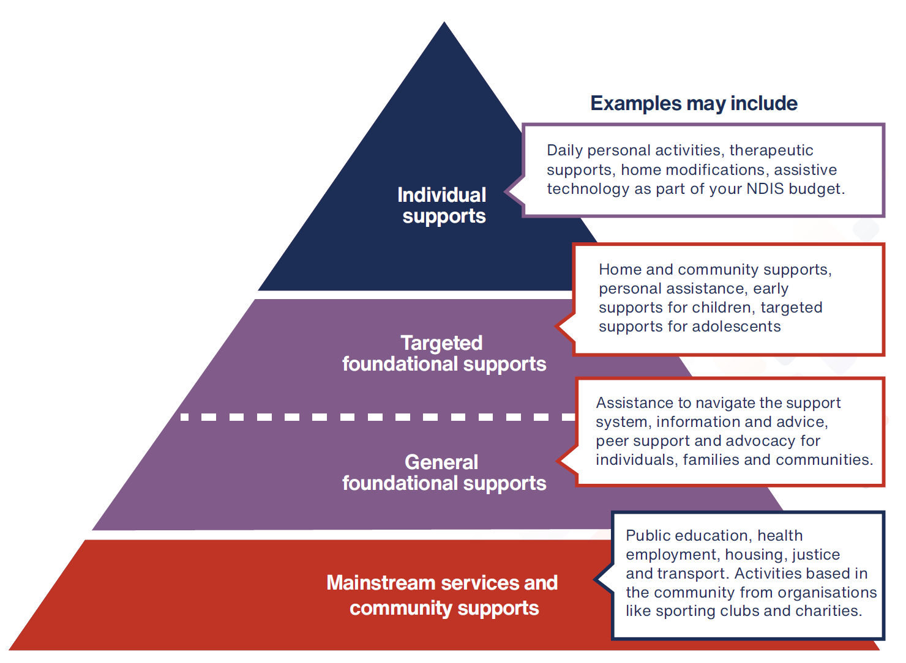
Want more information? Read the final NDIS Review report and recommendations, NDIS Review Guide, NDIS Review fact sheets and FAQ at www.ndisreview.gov.au

